**Demos**

**Introduction**

In these demos, you will automate Azure Synapse deployment using CI/CD pipelines from Azure DevOps.

This Demo shows how to create and collaborate with repository for Synapse workspace and how to deploy changes from development to QA environment automatically with the help of Azure DevOps pipeline.

**Estimated Time**

180 minutes

**Objectives**

Upon completing this Demo, you will be able to:

* Set up Azure DevOps Git Repository for Azure Synapse
* Create a release pipeline in Azure DevOps to automate deployment.

Summary of resources required for this exercise. You will be creating them in following exercises:

UNIQUESTRING: You will use this string to append with your resource name.

* Pick a 4 char string starting with a letter.
* Use only lower cases.
* It can be a combination of alphabets and numbers
* Example strings: “ab12”, “xy89”, “mn56”, “a12b”, “a1b2”
* Replace <UNIQUESTRING> with your value in the below table.

|  |  |  |
| --- | --- | --- |
| Azure Resource | Dev | QA |
| Resource Group | rg-synapse-dev | rg-synapse-qa |
| Synapse Workspace | <UNIQUESTRING>-synapse-dev  Example: ab12-synapse-dev | <UNIQUESTRING>-synapse-qa  Example: ab12-synapse-qa |
| Data Lake Gen 2 | <UNIQUESTRING>storagedev  Example: ab12storagedev | <UNIQUESTRING>storageqa  Example: ab12storageqa |
| Data Lake File Syatem | <UNIQUESTRING>filesysdev  Example: ab12filesysdev | <UNIQUESTRING>filesysqa  Example: ab12filesysqa |
| Dedicated SQL Pool | <UNIQUESTRING>sqlpooldev | <UNIQUESTRING>sqlpoolqa |
| Apache Spark Pool | <UNIQUESTRING>sparkdev | <UNIQUESTRING>sparkqa |

|  |  |
| --- | --- |
| Azure DevOps |  |
| Project Name | SynapseProject |
| SQL Repository Name | SynapseSQLRepo |
| Synapse workspace Repository Name | SynapseWSRepo |
| Infrastructure Repository Name | SynapseInfraRepo |
| Build Pipeline (SQL Project) | Synapse-SQL-Build |
| Build Pipeline (Infra Project) | Synapse-Infra-Build |
| Release Pipeline (Infra) | Synapse-Infra-Release |
| Release Pipeline (Synapse Workspace) | Synapse-Workspace-Release |
| Release Pipeline (Dedicated SQL Pool) | Synapse-DedicatedPoolSQL-Release |
| Release Pipeline (Serverless SQL) | Synapse-ServelessSQL-Release |
| Service Connection (dev resource group) | Conn_rg-synapse-dev |
| Service Connection (QA resource group) | Conn_rg-synapse-qa |

Table of Contents

Exercise 1: Create Azure Synapse Dev environment 3

Exercise 2: Create a Dedicated SQL Pool 9

Exercise 3: Deploy Spark Pool 15

Exercise 4: Set up Azure DevOps Project 18

Exercise 5: Setup repository for Synapse dev workspace 31

Exercise 6: Create and Publish data pipelines from Synapse Workspace 36

Exercise 7: Deploy Synapse workspace infrastructure for QA environment 54

Exercise 8: Dedicated SQL Pool deployment using Azure DevOps 74

Exercise 9: Serverless SQL deployment using Azure DevOps 85

Exercise 10: Synapse workspace release to QA environment 92

Exercise 1: Create Azure Synapse Dev environment

This exercise shows how to create an Azure Synapse environment using Azure portal.

Tasks

1. Sign in to Azure portal

*Sign in* to Azure portal by clicking <https://portal.azure.com/> with your Azure account.

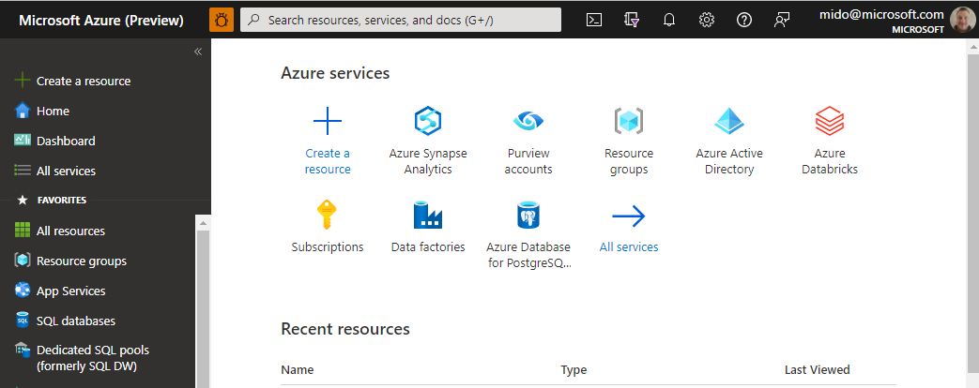

1. Create dev resource group ‘rg-synapse-dev’

This step creates a new Resource group for our workspace to be deployed into. Navigate to Resource Groups > click Create >

Create resource group by providing below values:

* + - Subscription: Choose your subscription
    - Resource Group: rg-synapse-dev
    - Choose a region closest to your geographical location

Click ‘*Review and Create*’ to create the resource group

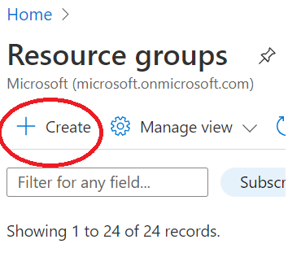

1. Choose Azure Synapse Analytics from marketplace.

In the portal, go to "Create a Resource". Type in "Synapse", then choose Azure Synapse Analytics.

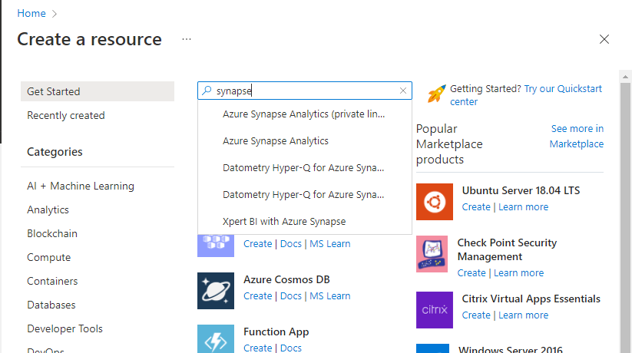

In the next window, click "Create"

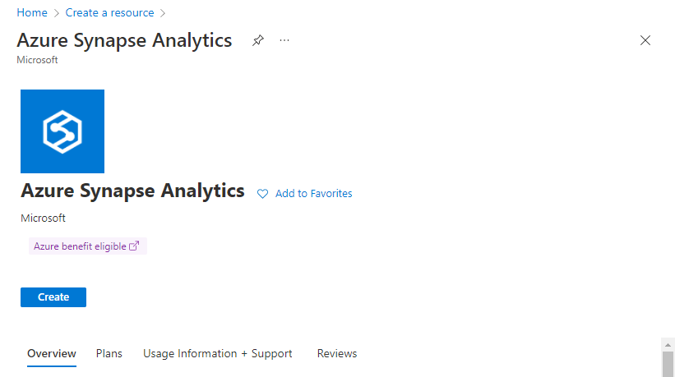

1. Create Synapse Workspace

In the Basics pane, choose your Azure Subscription to use for deploying the Workspace. Then populate the following screens. You will need to populate the following fields -

* 1. Resource Group : rg-synapse-dev
  2. Managed Resource Group : Leave empty
  3. Workspace name : <UNIQUESTRING>-synapse-dev (*Note: replace <UNIQUESTRING> with the value*)
  4. Use Spark On Cosmos : Unchecked
  5. Region : (Choose the region closest to your location)
  6. Data Lake storage Gen2
     1. Account Name: <UNIQUESTRING>storagedev
     2. File System Name: <UNIQUESTRING>filesysdev

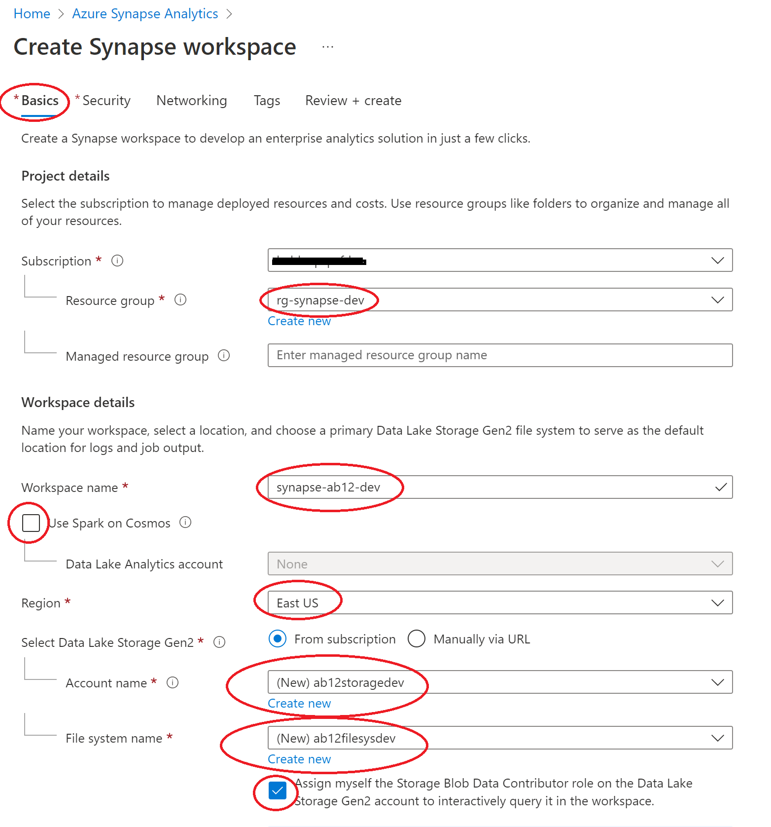

1. Create Workspace – Security Blade

Following this, move to the Security blade and complete as per the screenshot below, choose a username and password of your own choosing that you can remember as you will need this for later in the Demo:-

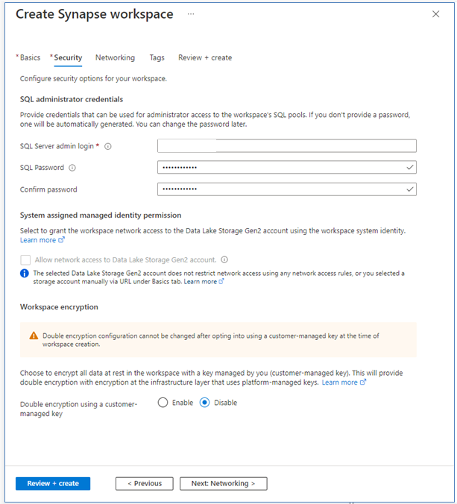

With those blades complete, you can now click “Review + Create” to deploy your workspace, click “Create” on the final validation screen -

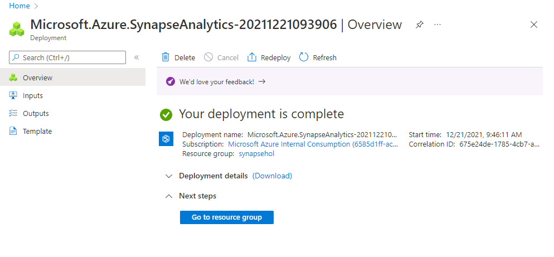

Exercise 1 has been completed

Exercise 2: Create a Dedicated SQL Pool

This exercise shows how to create a Dedicated SQL Pool in an existing Synapse Workspace.

Tasks

1. Sign in to Azure portal

*Sign in* to Azure portal by clicking <https://portal.azure.com/> with your Azure account.

1. Navigate to the Workspace Created in Exercise 1

Go to your deployed resource group from the previous exercise. You can do this by either following the link from the deployment screen below -



OR, you can find the workspace from the Azure Portal, you can find your new Workspace in Recent Resources or by clicking the Synapse Analytics icon at the top, which will show all your Workspaces. You can also type in the name in the top search bar to find it.

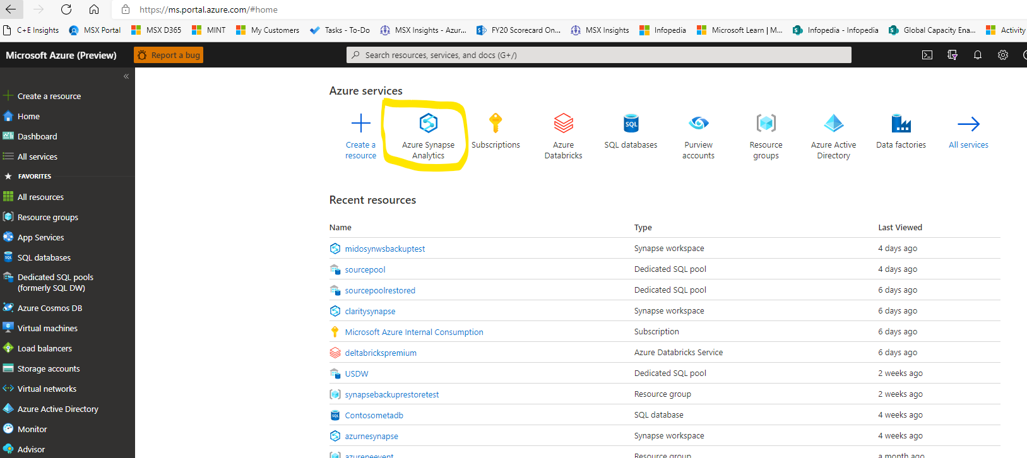

In your resource group (click directly on the Workspace name if you went to it via the portal), click on the Synapse Workspace that you deployed -

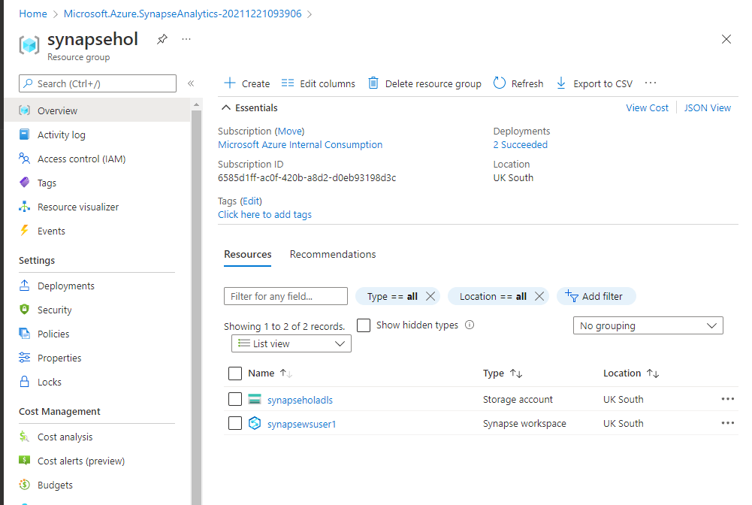

In the Workspace, click “Open Synapse Studio” to open the Studio GUI

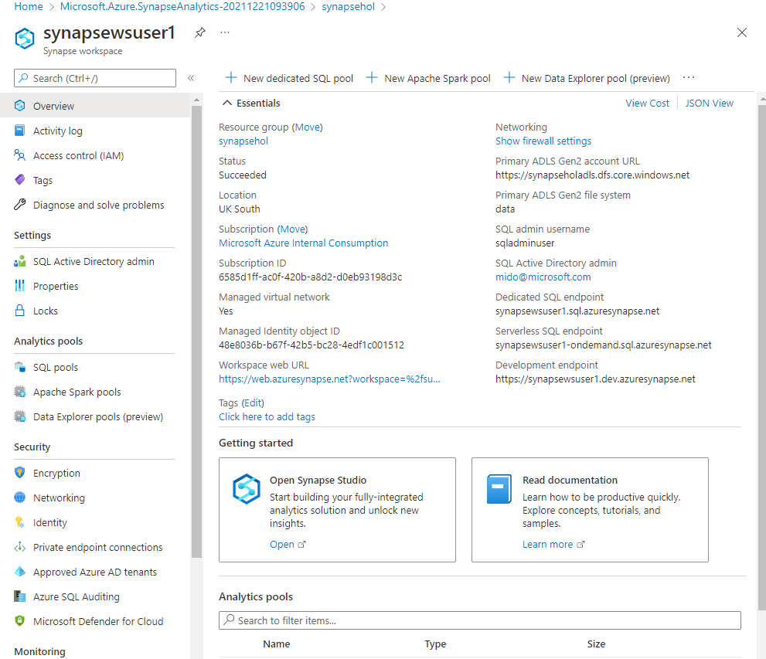

1. Adding a Dedicates SQL Pool

In your workspace, go to “Manage” on the left hand menu -

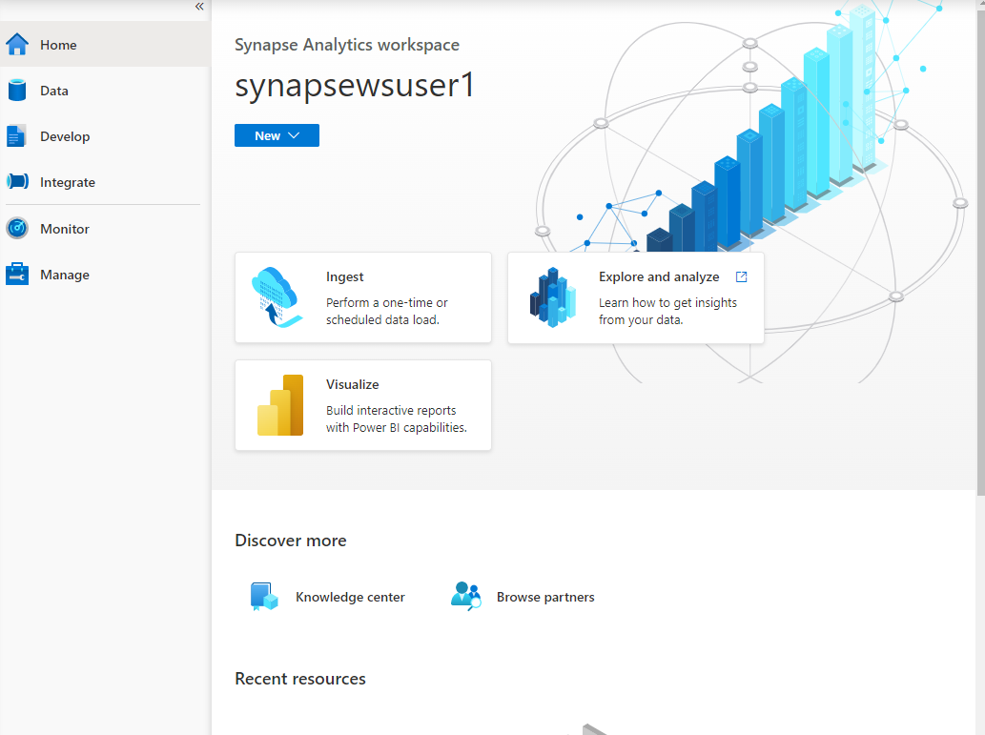

Under Manage, choose “SQL Pool” at the top, then click “New” in the main window –

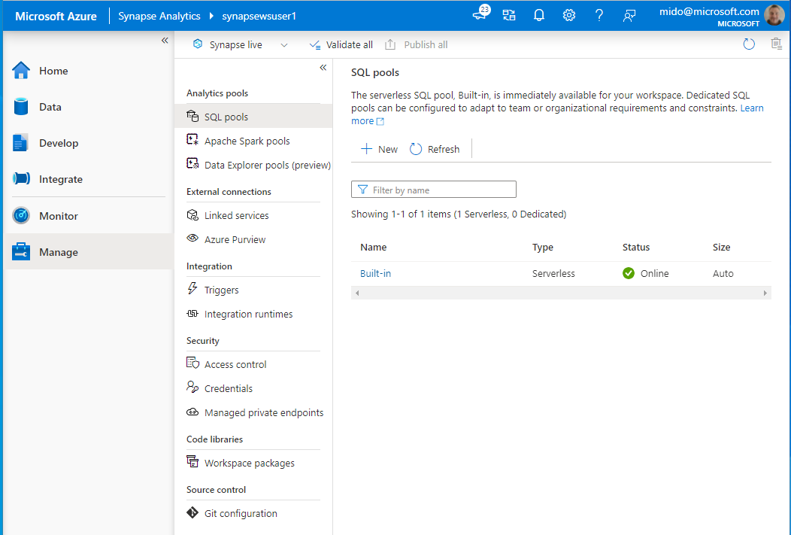

* SQL Pool a name: <UNIQUESTRING>sqlpooldev
* Performance Level: DW100c

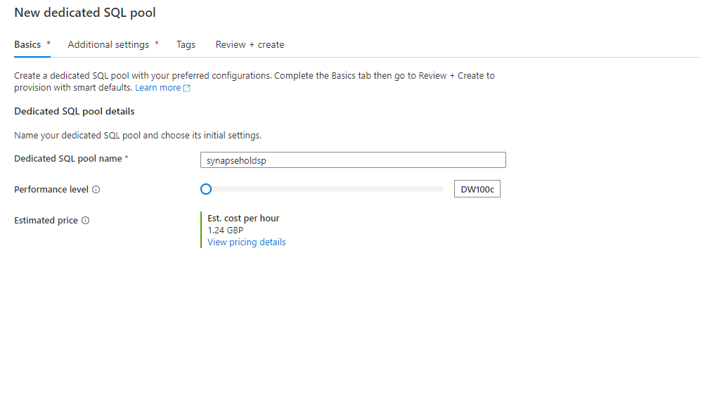

Click “Review + Create”, then “Create” - this will deploy your SQL pool –

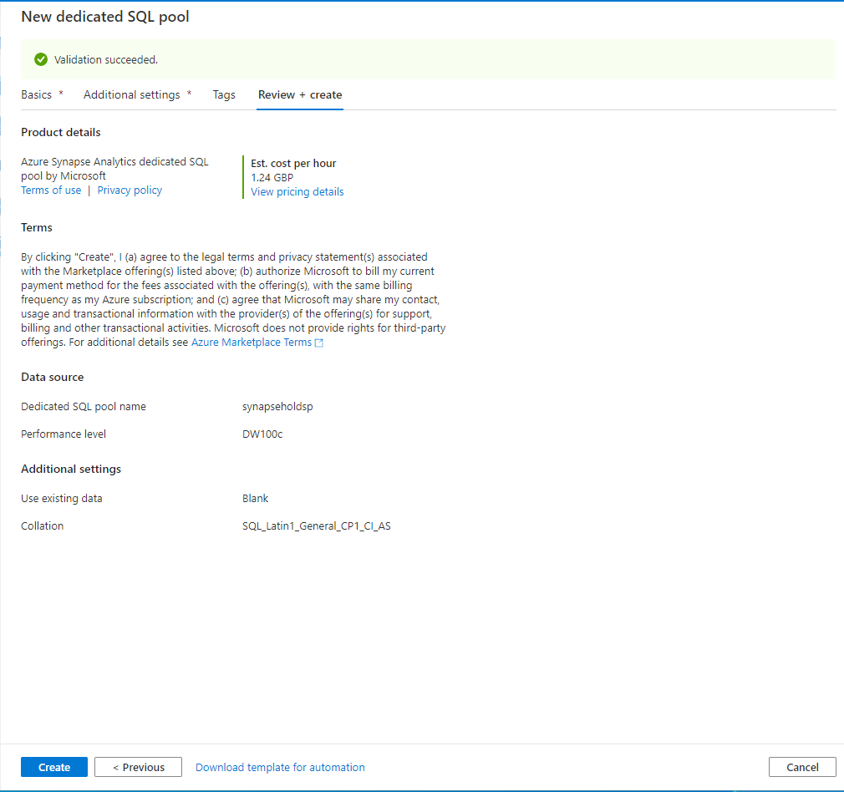

Exercise 2 has been completed

Exercise 3: Deploy Spark Pool

This exercise shows how to deploy a Spark Pool into the Synapse Workspace

Tasks

1. Sign in to Azure portal

*Sign in* to Azure portal by clicking <https://portal.azure.com/> with your Azure account.

1. Navigate to Workspace

Navigate to your Synapse Workspace you were using in previous exercises.

1. Add New Spark Pool

In the Manage section, go to Apache Spark Pool and click “New”

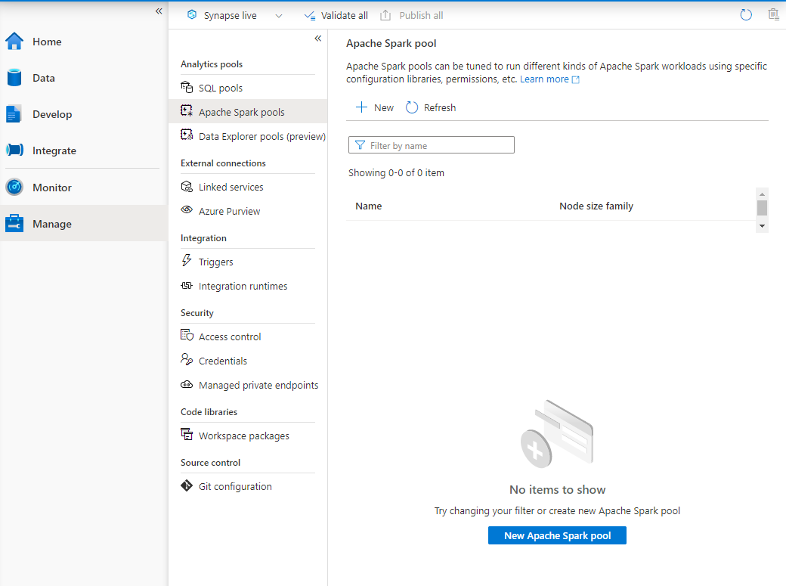.

* + Apache Spark pool name: <UNIQUESTRING>sparkdev (Name must be between 1 and 15 characters long)
  + Node size family: Memory optimized
  + Node size: Small
  + Autoscale: Enabled
  + Number of Nodes: 3
  + Dynamically allocate executors: Disabled

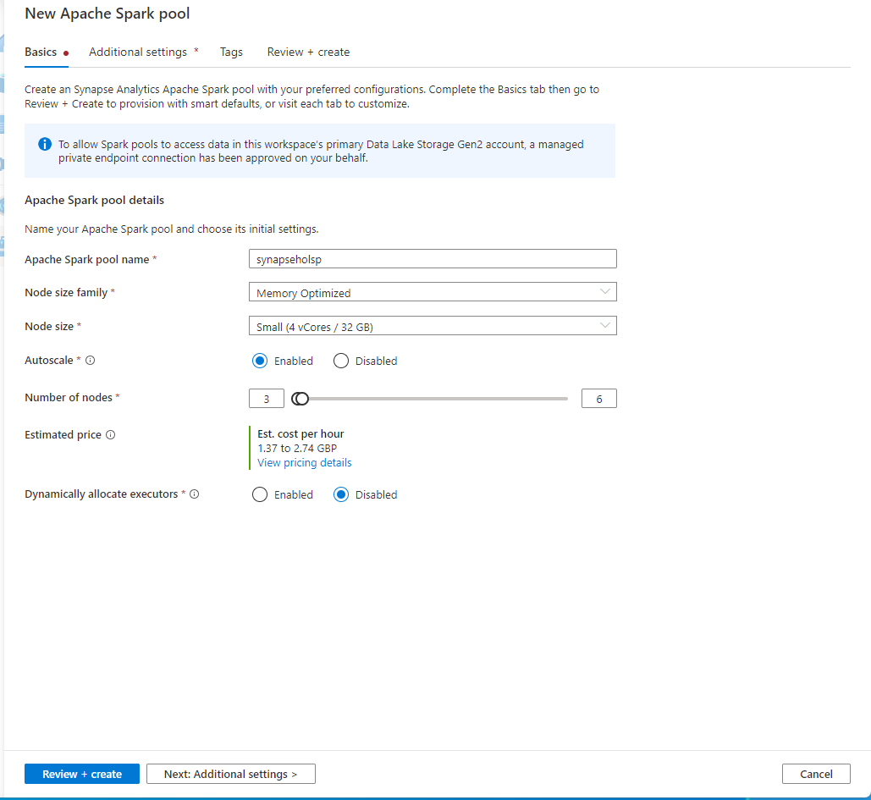

Click “Review + Create” and then “Create” and your Spark Pool will now be avaiDemole for use (note, Spark Pools are serverless, and only start up when work is submitted to them).

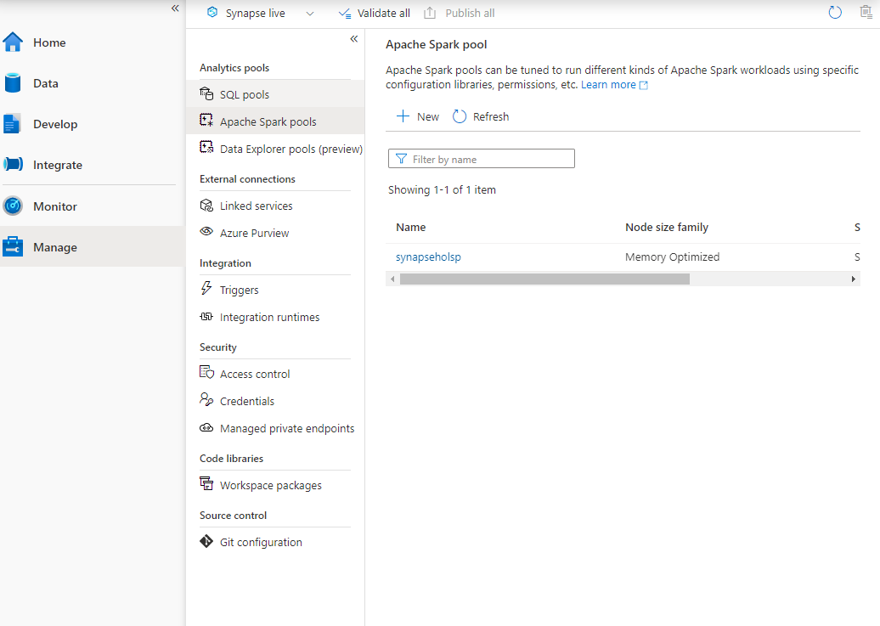

Exercise 3 has been completed

Exercise 4: Set up Azure DevOps Project

This exercise shows how to set up an Azure DevOps project and its components.

Tasks

1. Sign in Azure DevOps

S*ign in* Azure DevOps by clicking <https://dev.azure.com/> with your Azure DevOps account.

If you do not have one, first *Sign up* by clicking *Start Free* and click *Create* after giving a unique name for the *Azure DevOps organization* and the *region*. (free for 12 months )

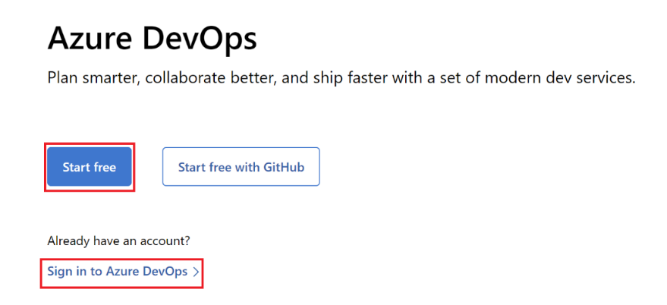

1. Create a project

If it will be your first project, you will see that *Create a project to get started* menu will appear by default.

If it is not your first one, click  *New Project* on the upper right corner of the page.

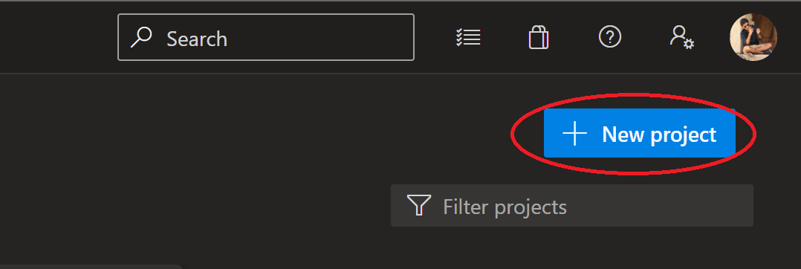

|  |  |
| --- | --- |
| Enter/select below values and click ‘Create’  Project Name:  *Synapse Project*  *Click on Advanced to select the Version control and the Work Item Process*  Version control:  *git*  Work Item Process:  *Agile* |  |

1. Import SQL repository

Select ‘Repos’ from the left-hand menu, click on repository dropdown at the top center of the screen and click on ‘Import repository’

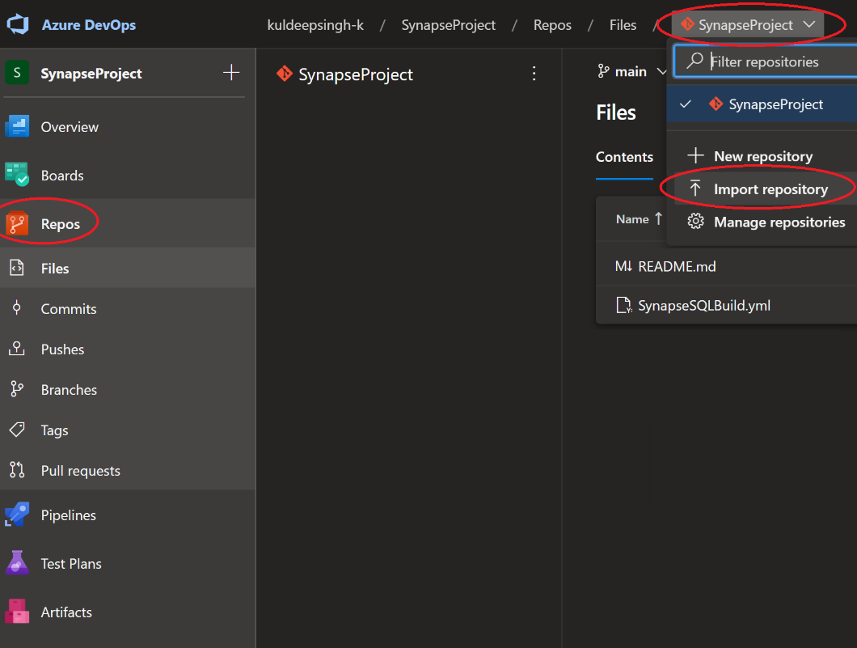

|  |  |
| --- | --- |
| Enter below values and click ‘Import’  Repository Type:  *Git*  Clone URL:  *https://dev.azure.com/CSU-UK-Data/PublicRepoProject/_git/SynapseSQLRepo*  Require Authentication:  *Uncheck*  Name:  *SynapseSQLRepo* |  |

1. Import Infrastructure repository

Select ‘Repos’ from the left hand menu, click on repository dropdown at the top center of the screen and click on ‘Import repository’



|  |  |
| --- | --- |
| Enter below values and click ‘Import’  Repository Type:  *Git*  Clone URL:  *https://dev.azure.com/CSU-UK-Data/PublicRepoProject/_git/SynapseInfraRepo*  Require Authentication:  *Uncheck*  Name:  *SynapseInfraRepo* |  |

1. Create new repository for Synapse workspace

Select ‘Repos’ from the left hand menu, click on repository dropdown at the top center of the screen and click on ‘New repository’

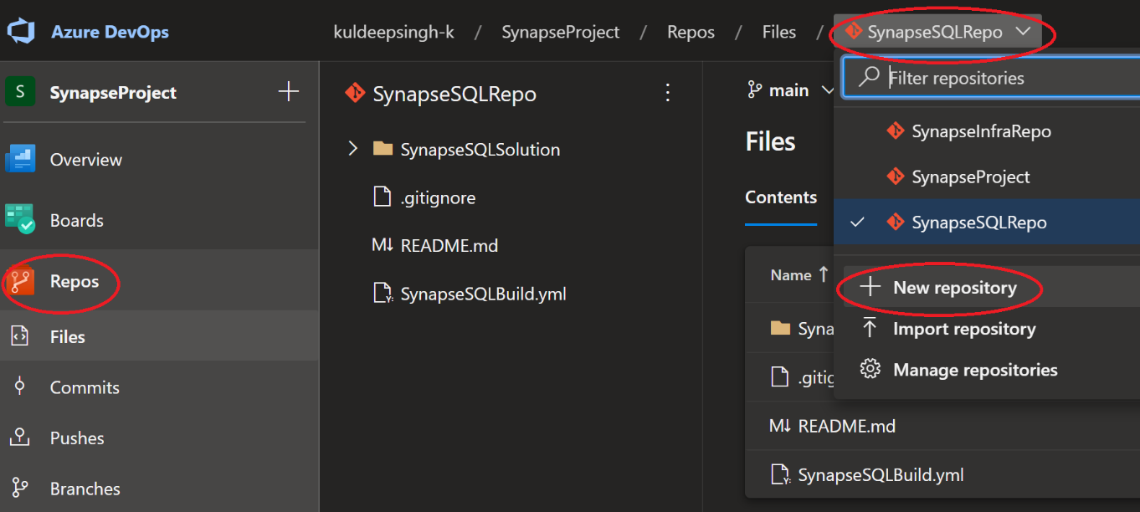

|  |  |
| --- | --- |
| Enter below values and click ‘Create  Repository Type:  *Git*  Repository Name:  *SynapseWSRepo*  Add a README:  *Checked*  Add a .gitignore:  *VisualStudio* |  |

1. Verify all the repositories

Select ‘Repos’ from the left hand menu, click on repository dropdown at the top center of the screen and verify that you have all the 4 repositories as shown in image.

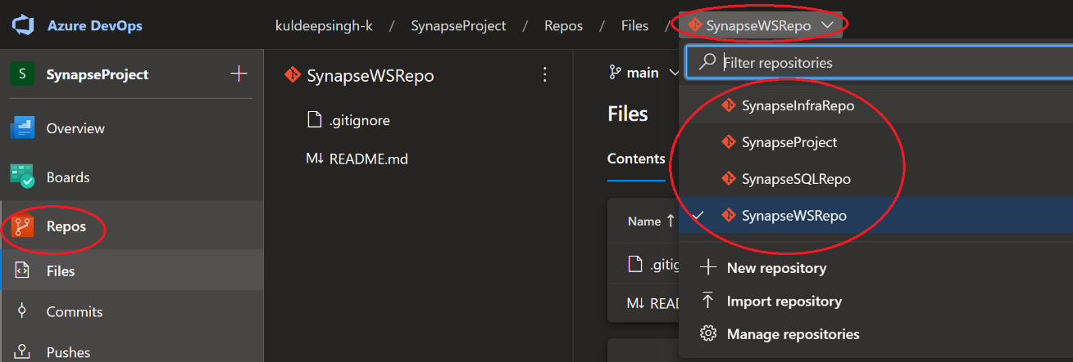

1. Create a service connection from Azure DevOps to dev resource group.

Navigate to Project settings from the gear icon on the bottom left of the screen. Select Service connections and click Create Service Connection.

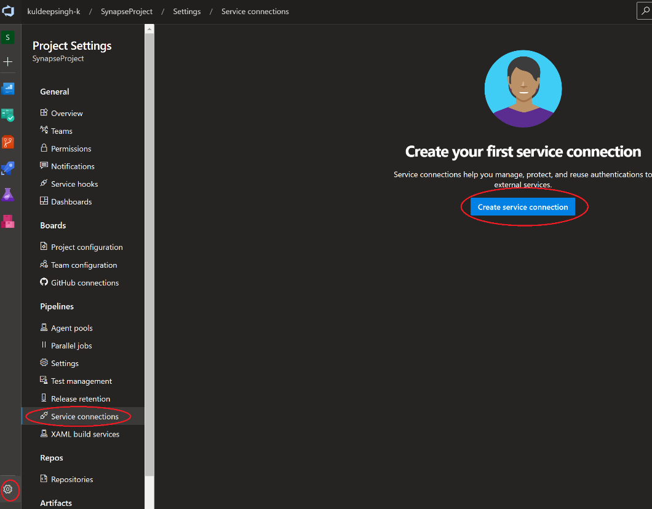

On new connection screen select ‘Azure Resource Manager’ and then select ‘Service principal (automated)’

|  |  |
| --- | --- |
|  |  |

|  |  |
| --- | --- |
| Enter/select below values and click ‘Save’  Scope Level: *Subscription*  Subscription: *Select your working subscription*  Resource Group: *rg-synapse-dev*  Service Connection Name: *Conn_rg-synapse-dev*  Grant access permission to all pipelines: *checked* |  |

1. Add permissions for Service Connection

Navigate to newly created service connection ‘Conn_rg-synapse-dev’. Click on it.

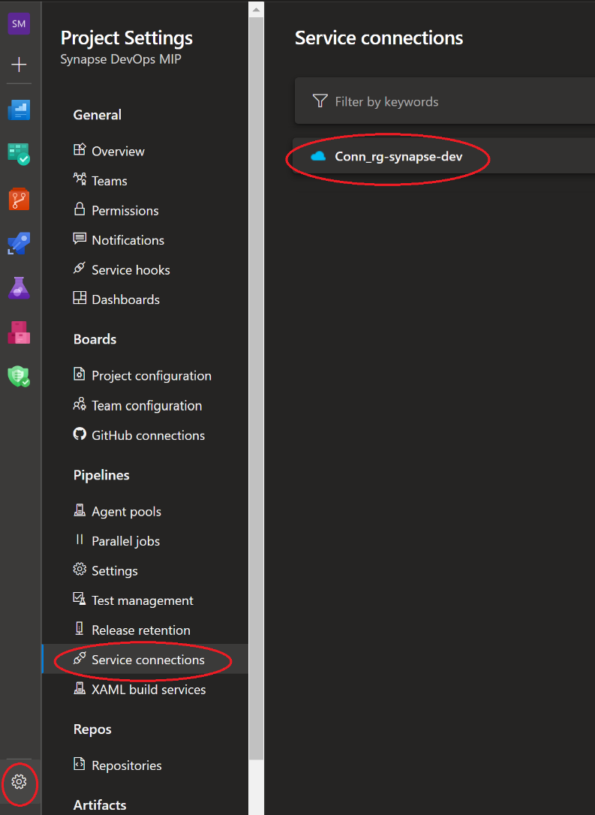

Click on the link ‘Manage Service Principal’

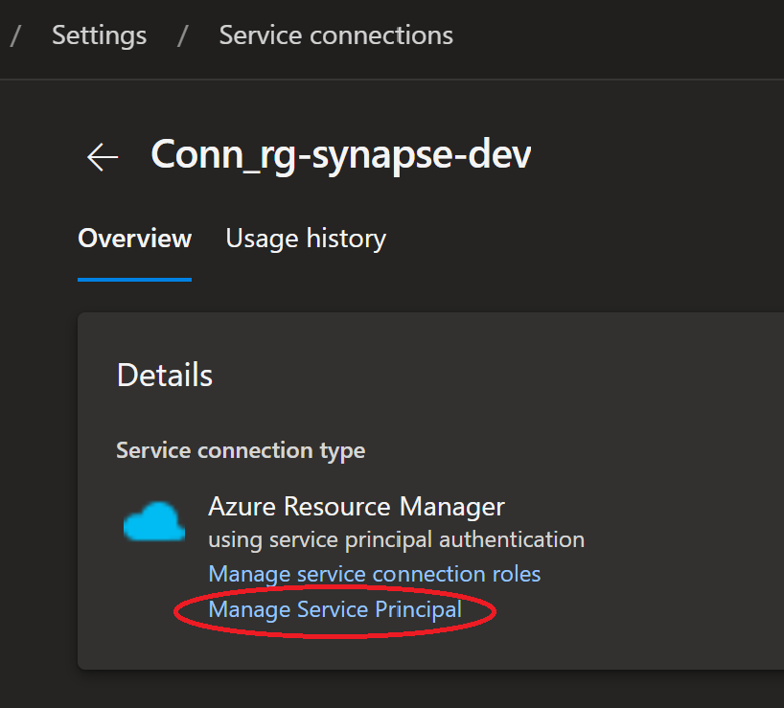

This link will navigate you to the Azure portal, where you have to **copy the ‘Display name’ from Overview tab.**

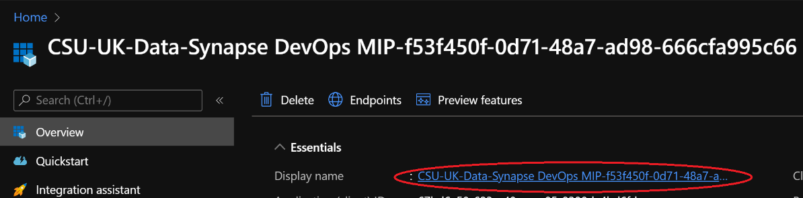

Navigate to your dev resource group ‘rg-synapse-dev’ and add Role assignments for ‘User Access Administrator’ role.

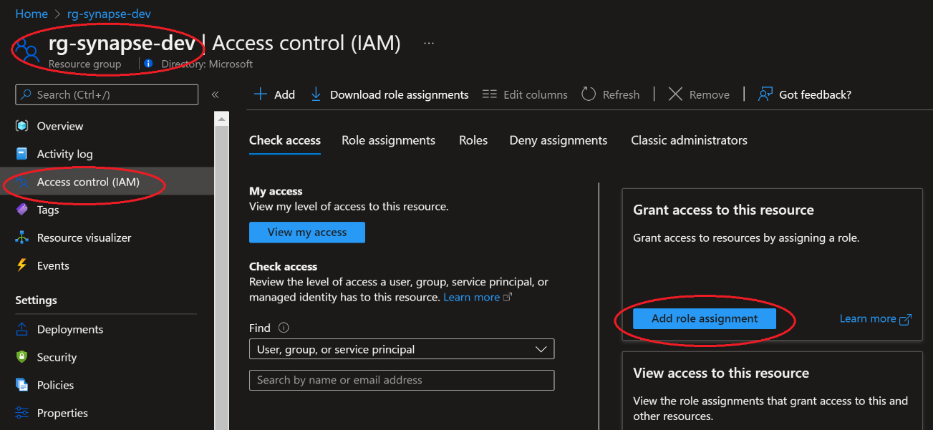

Select ‘User Access Administrator’ role and click next

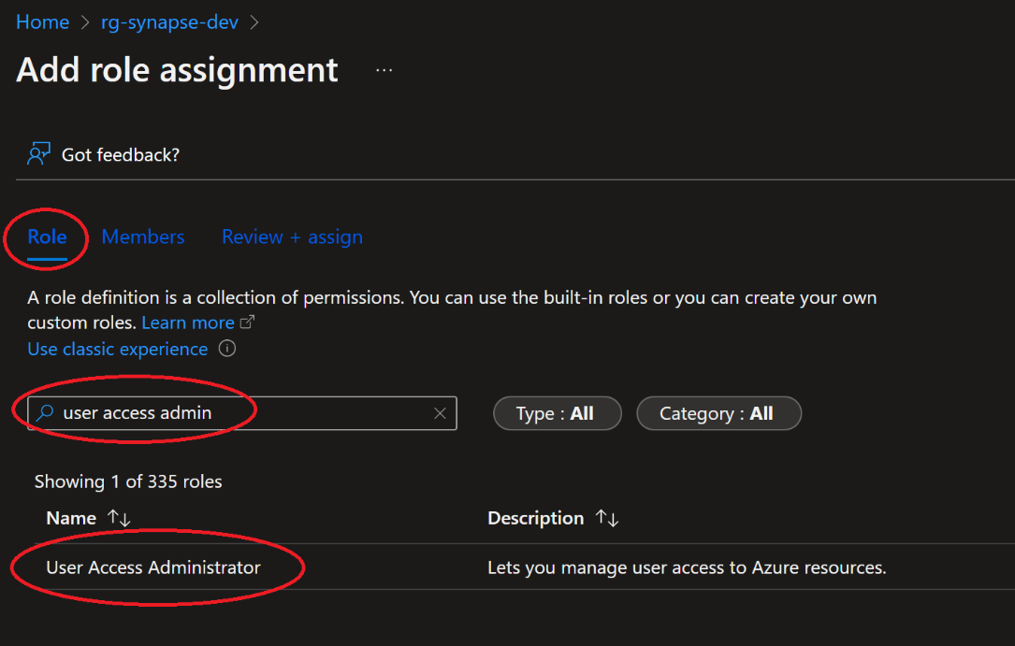

On the members tab, Click ‘Add Members’ then search for the application name copied in above ‘Copy Display Name’ step.

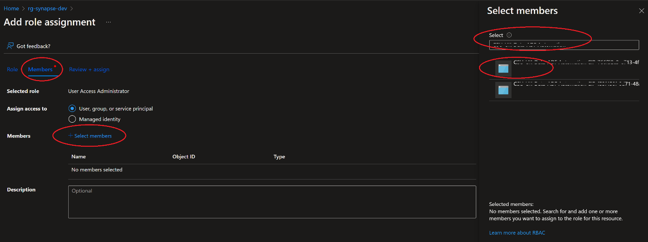

Click ‘Review and Assign’ to add the permissions.

Exercise 4 has been completed

Exercise 5: Setup repository for Synapse dev workspace

This exercise shows how to link your Azure synapse Dev environment with Azure DevOps repository.

Tasks

1. Sign in to Azure portal

*Sign in* to Azure portal by clicking <https://portal.azure.com/> with your Azure account.

1. Select Azure Synapse instance created in *Exercise 1*.

Search for ‘Azure Synapse’ in the top search box and select ‘Azure synapse Analytics’ under services.

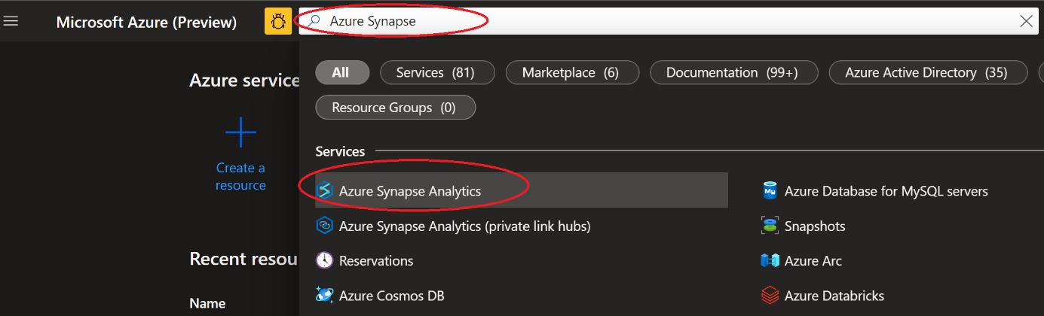

Select the Synapse workspace (synapse-<UNIQUESTRING>-dev) created in *Exercise 1*

From the overview tab open synapse studio

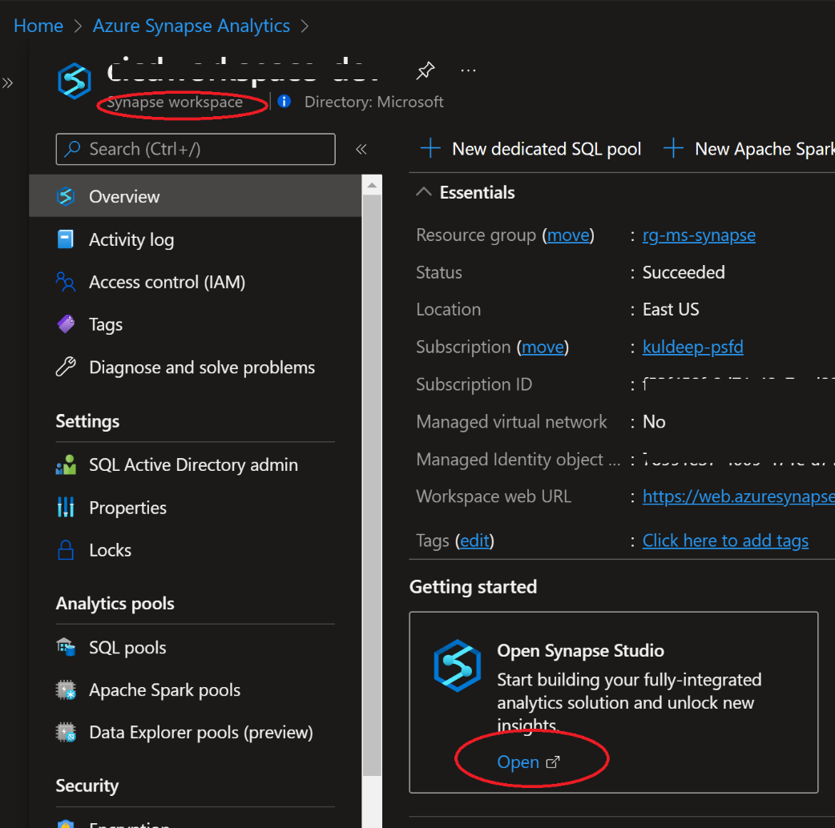

On Synapse Analytics workspace home screen, select manage from left hand navigation. Select Git configuration and click on Configure button.

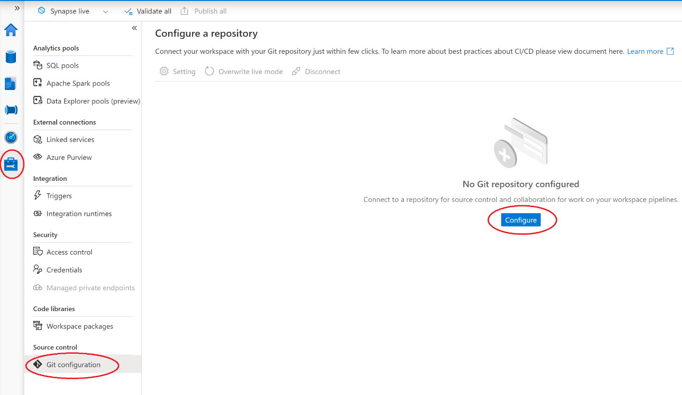

Select Azure DevOps git as the repository type and select your AAD connected to your Azure DevOps account.

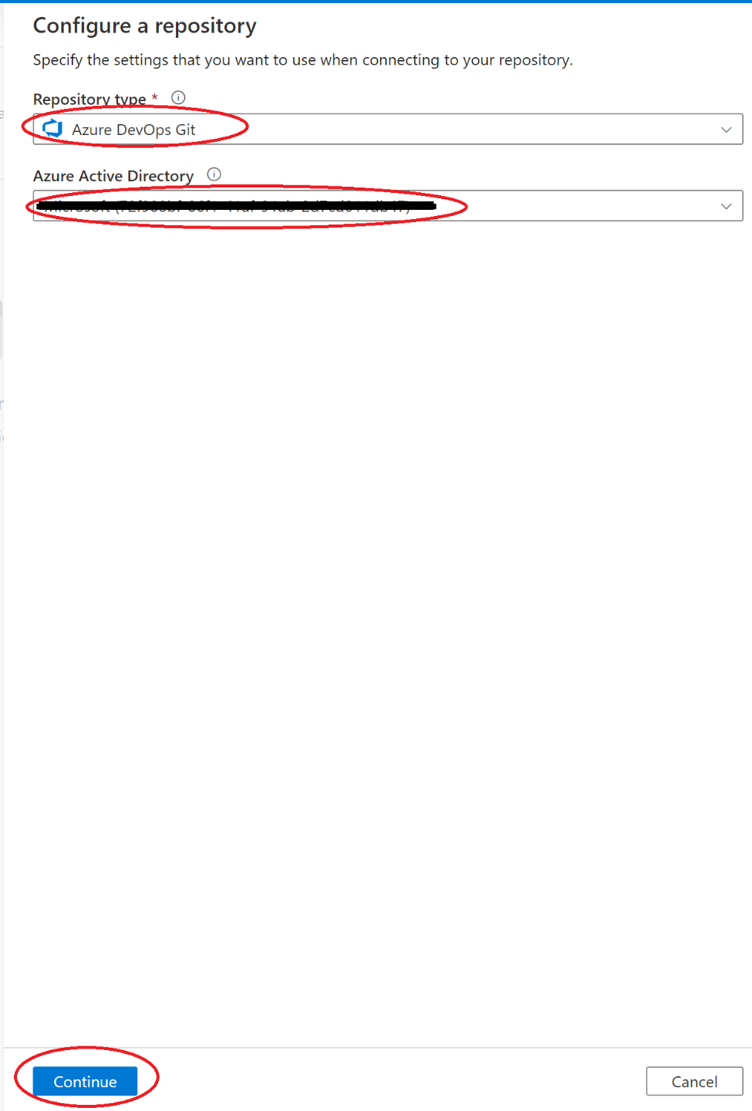

Configure repository as below:

* Azure DevOps organization Name: Organization name from *Exercise 4*
* Project Name: Project created in *Exercise 4* (SynapseProject)
* Repository Name: SynapseWSRepo
* ColDemooration branch: main
* Publish branch: workspace_publish

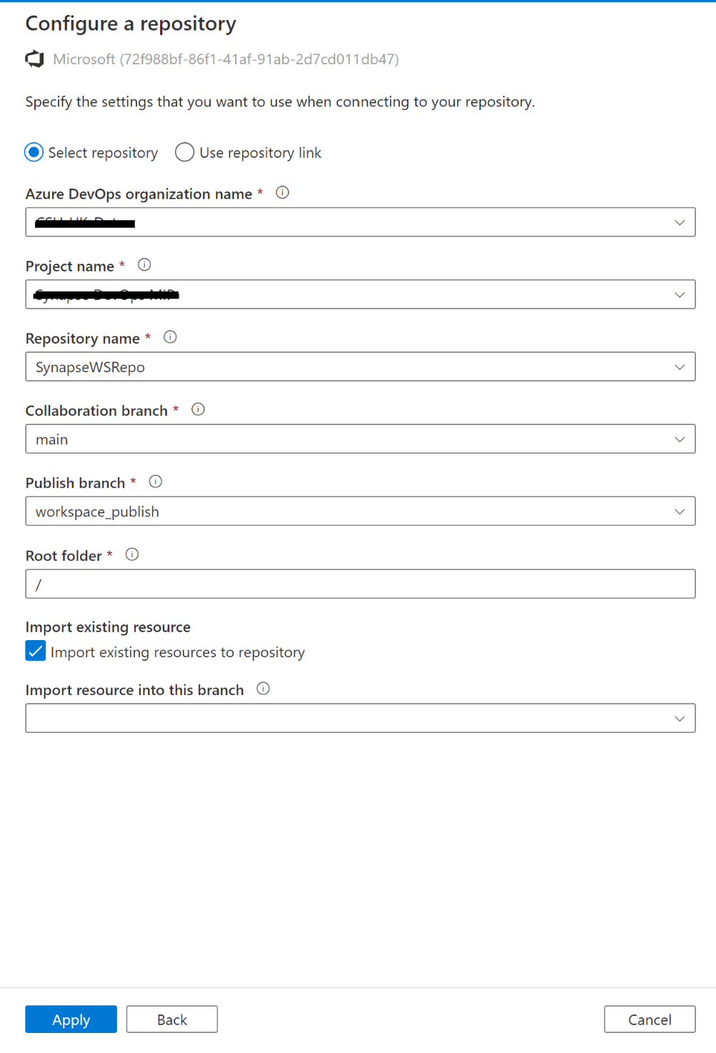

Select Main as the working branch and click Apply.

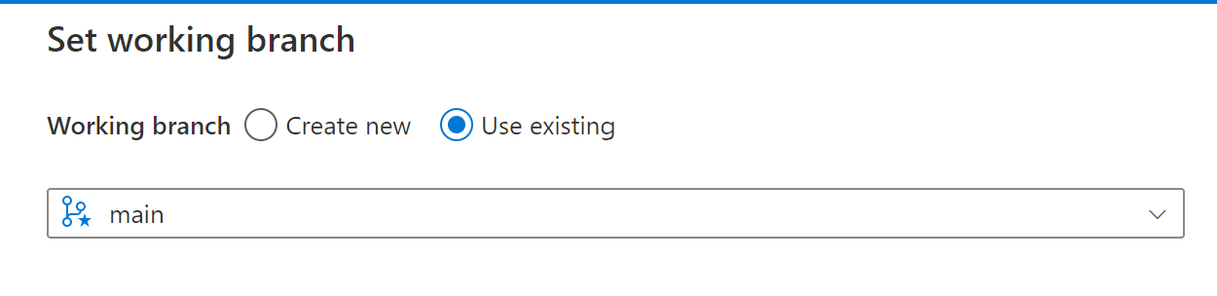

1. Verify git configuration for synapse workspace

On the git configuration screen verify the organization name, project name and repository. Verify that you are into main branch and you can see publish button.

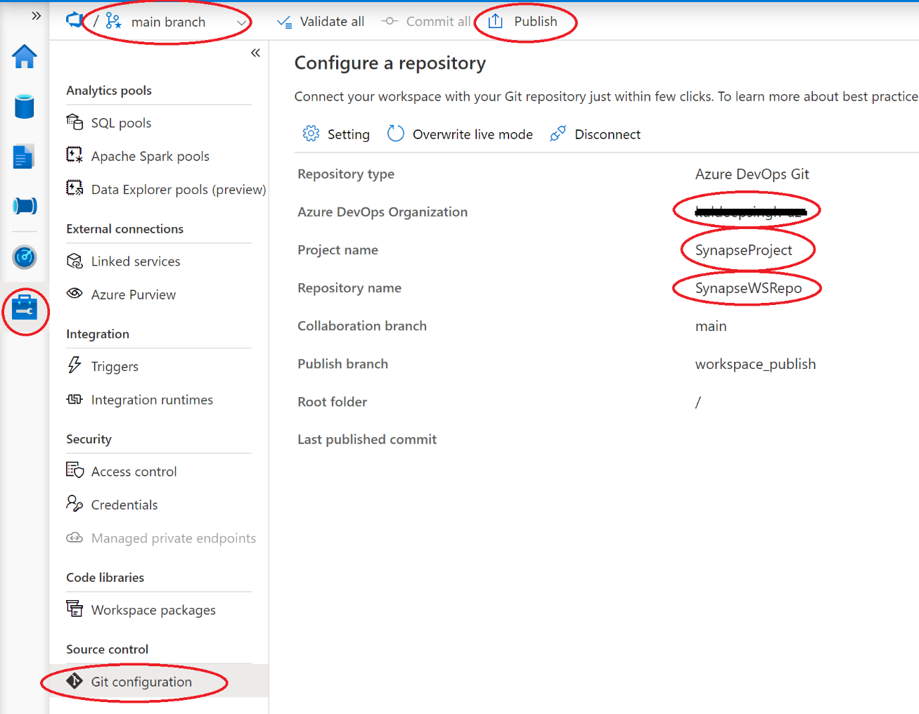

Exercise 5 has been completed

Exercise 6: Create and Publish data pipelines from Synapse Workspace

This exercise shows how to use the configurations completed in Exercise 5 to create a new feature (copy activity) in the Synapse Workspace and merge it back into the main branch.

Tasks

1. Sign in to Azure portal

*Sign in* to Azure portal by clicking <https://portal.azure.com/> with your Azure account.

1. Navigate to Workspace

Navigate to your Synapse Workspace you were using in previous exercises.

1. Prerequisites – Upload Sample Data

In order to complete this Exercise, you need some sample data. Feel free to use your own, however for this exercise the csv file here - [Country names - GOV.UK (publishing.service.gov.uk)](https://assets.publishing.service.gov.uk/government/uploads/system/uploads/attachment_data/file/1055492/FCDO-geographical-names-index-Feb22.csv/preview) was used.

Click the link provided and download the csv file to your local computer.

Then, in the Workspace, navigate to the Data tab on the left, select Linked, then expand your data lake linked to the workspace.

Click the filesystem to open up the storage explorer window.

Click Upload file and upload to your default container.

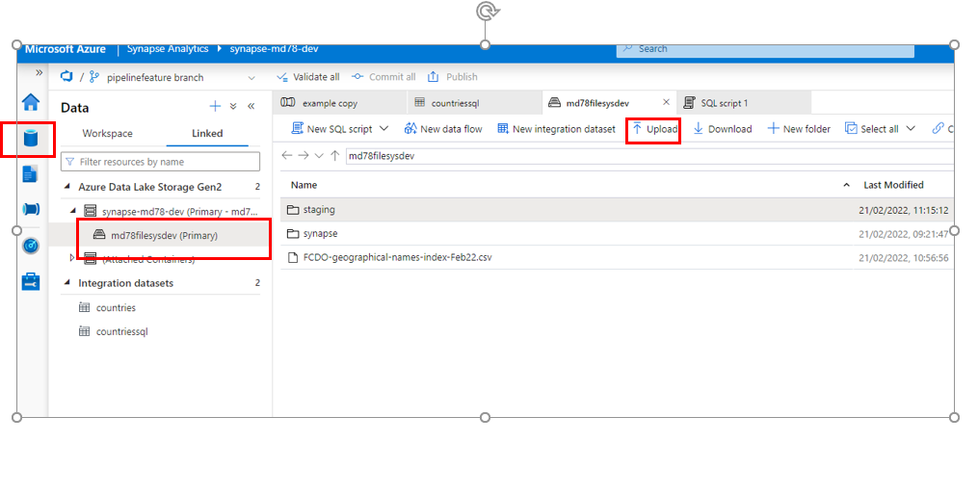

The file will be visible in the explorer. Take a note of this location for later steps in this Demo.

1. Create new feature branch

Click the “Integrate” icon on the left navigation, then click the drop-down arrow next to the main branch link to git.

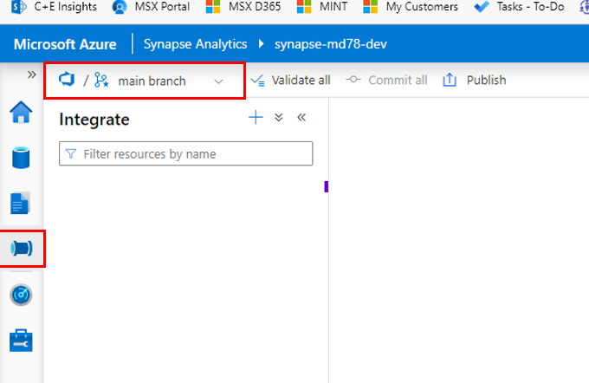

1. Create Branch

Select “+ New Branch”

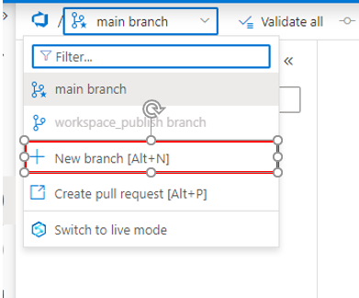

Give your new branch a name, then click “Create”.

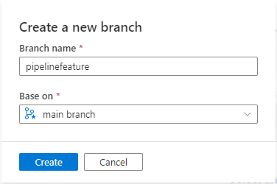

1. Create Copy Pipeline

In this step you will create a simple copy pipeline that will copy data from a file in your data lake to the Synapse Dedicated Pool you created in Exercise 2

First of all, select the new feature branch you created in the previous steps (it should automatically be selected) –

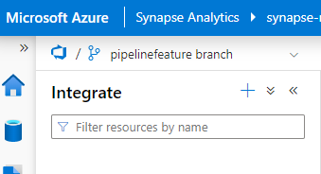

Then, create a new pipeline by clicking Integrate, then the “+”, then Pipeline –

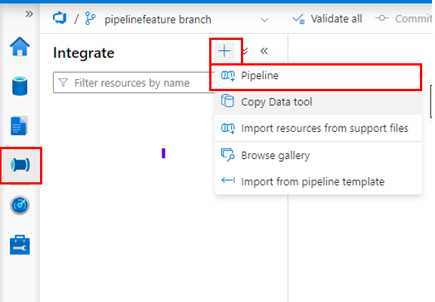

In the properties of the pipeline – give it a name ***countriessql***

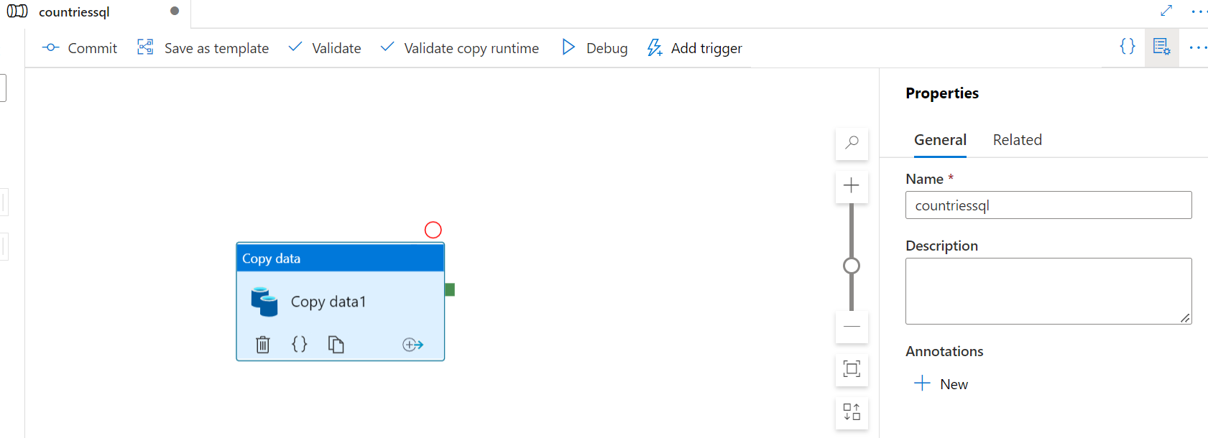

1. Create Copy Activities

In your created pipeline, under Activities, expand “Move & Transform”, then drag “Copy Data” into the canvas.

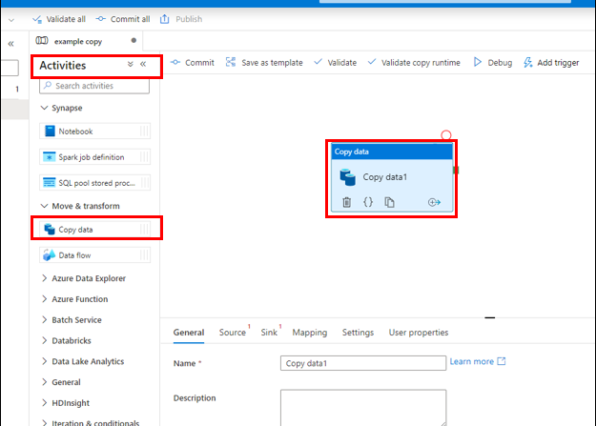

1. Create a Source

With your Copy data activity selected, click “Source” in the bottom pane, then click + New to create a new dataset.

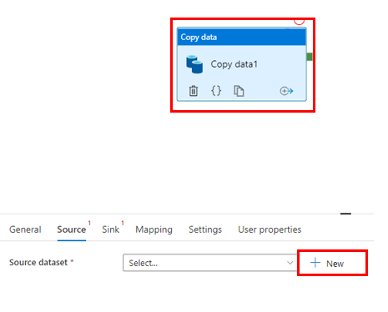

In the next window, scroll down until you find your Azure Data Lake Storage Gen2, then click Continue –

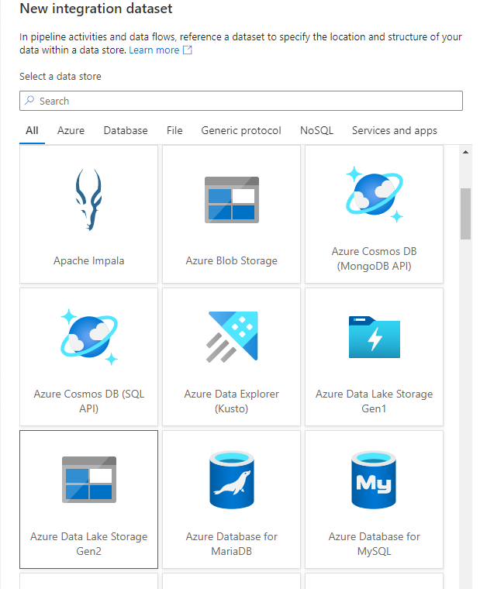

In the next screen, click DelimitedText and click continue –

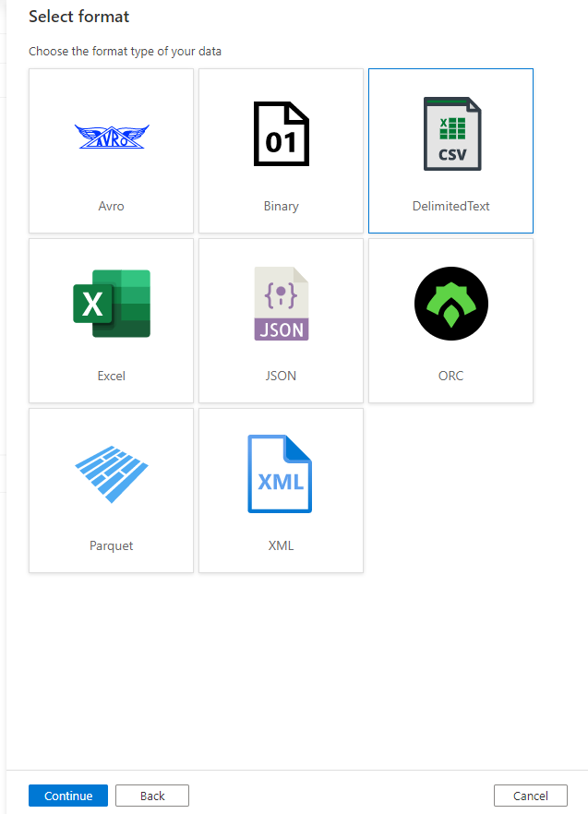

In the following screen, give the dataset a name (“Countries”) and in the Linked Service drop down choose the one corresponding to the data lake you linked/created when you created the Synapse Workspace.

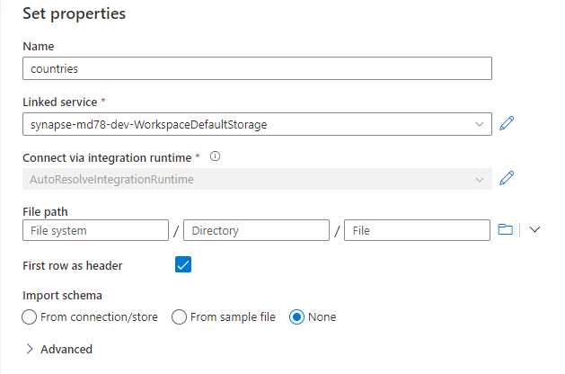

In the File Path, click the folder icon and navigate to the file you uploaded earlier.

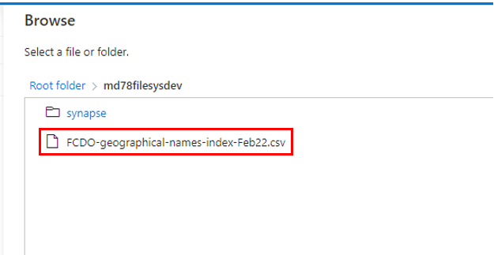

Click OK, and your Source pane should look like this –

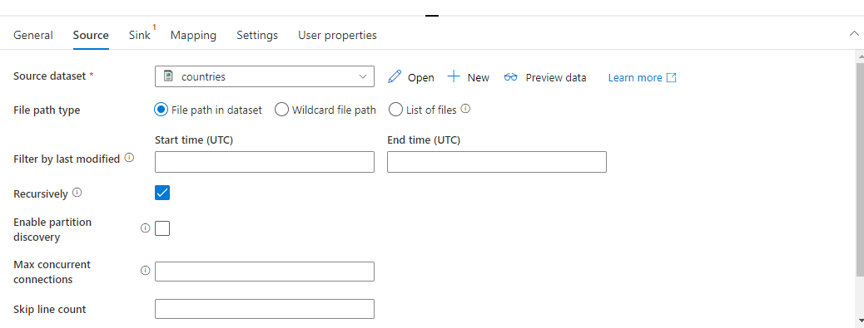

1. Create a Sink

In the same window, click “Sink”, then click +New

In the New Integration dataset screen, scroll and select “Azure Synapse dedicated SQL pool”

Click Continue

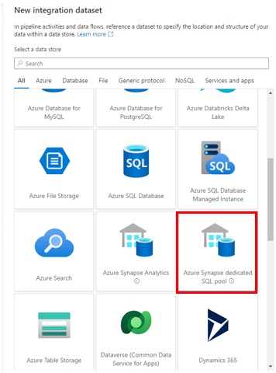

In the following screen, give your dataset a name.

Choose the SQL Pool you created in Exercise 2.

Click “Edit” underneath Table name (as we’re going to be creating the table with the load)

and fill in as per the screen shot below.

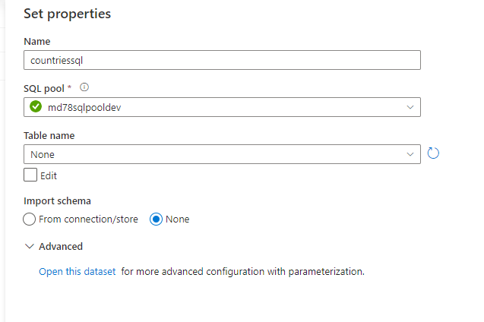

Finally, click “Open this dataset for more advanced ….”

In the dataset screen that opens up, fill in the table name as per the screenshot below –

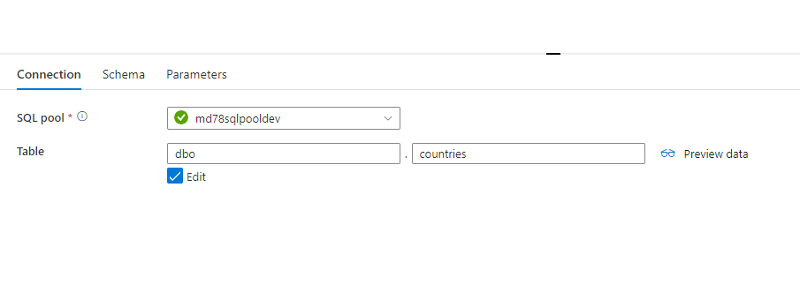

Finally, select the pipeline window, and amend the Table option to “Auto Create table”. This will create a table with the name as configured in the previous step.

Also, in this screen, select the copy method of Polybase

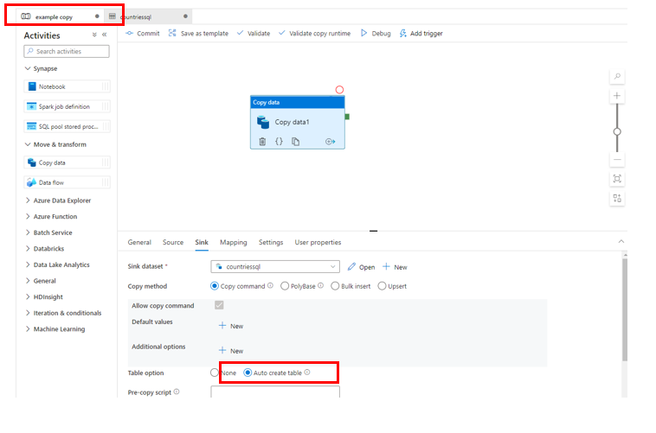

1. Configure Staging directory

As we’re copying from the data lake to SQL Pool, best practice is to use Staging which allows for optimized ingestion into the SQL Pool.

Open the Data tab, expand the default Azure Data Lake Storage Gen2, then select your storage account.

In the screen that loads up, click “New Folder”, then give it a name of “Staging” –

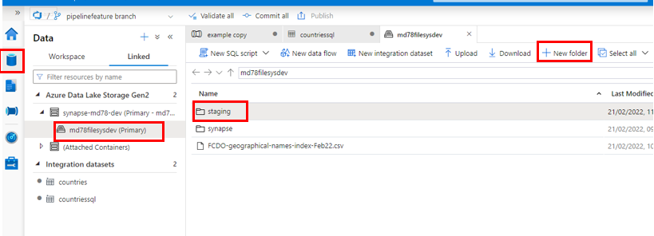

1. Configure Pipeline to use Staging

Select your pipeline again, then click the Copy Activity, then click Settings.

In Settings, check the “Enable Staging” box, then choose your default storage account in the linked service.

Finally, click Browse, and navigate to the Staging folder you created in the previous step.

1. Run the pipeline

We can now run the pipeline to copy the data into your SQL Pool.

In the pipeline screen as before, click “Debug” to run the Copy activity

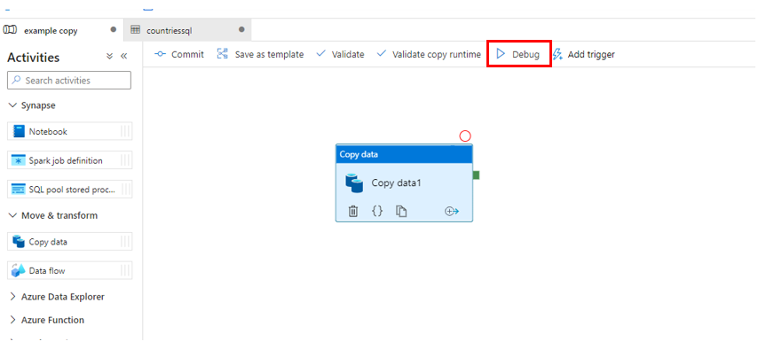

Your pipeline should run successfully –

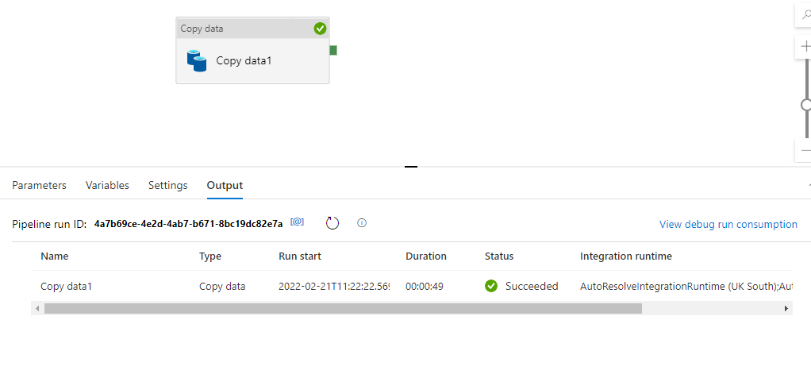

1. Validate Copy

You can now validate the data has been copied successfully. To do this, click the Data tab on the left, choose Workspace, then select your SQL Pool.

Expand tables, and you should see dbo.countries (or whatever you called your table).

Right click the table, select “New SQL script”, then “Select TOP 100 rows”.

You should now see your copied rows returned.

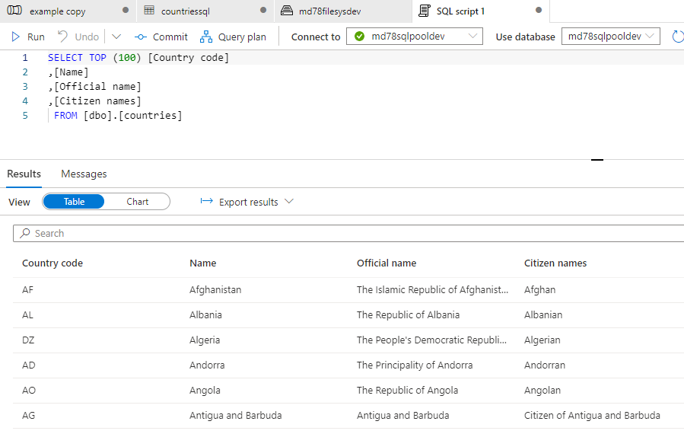

1. Merge changes back into main branch.

With your pipeline created, you are now ready to commit the changes to your feature branch and create a pull request to merge it back into the main branch in your repository.

First, click “Commit all” to commit your changes to the feature branch –

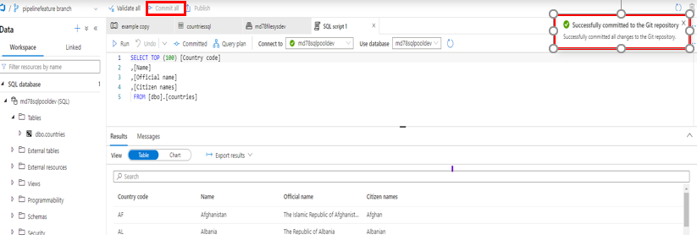

Next, click on the repository branch drop down, then choose Create pull request –

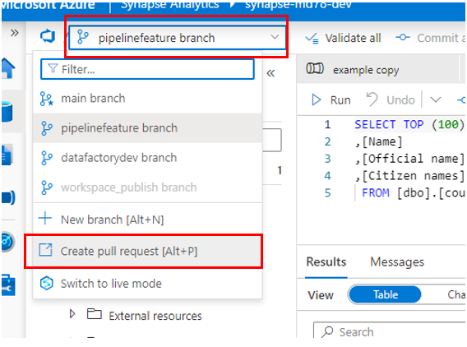

This will open up the Azure devops portal. From here, you can amend the title and add notes around your pull request. Feel free to put your own in here or leave as is.

Click Create

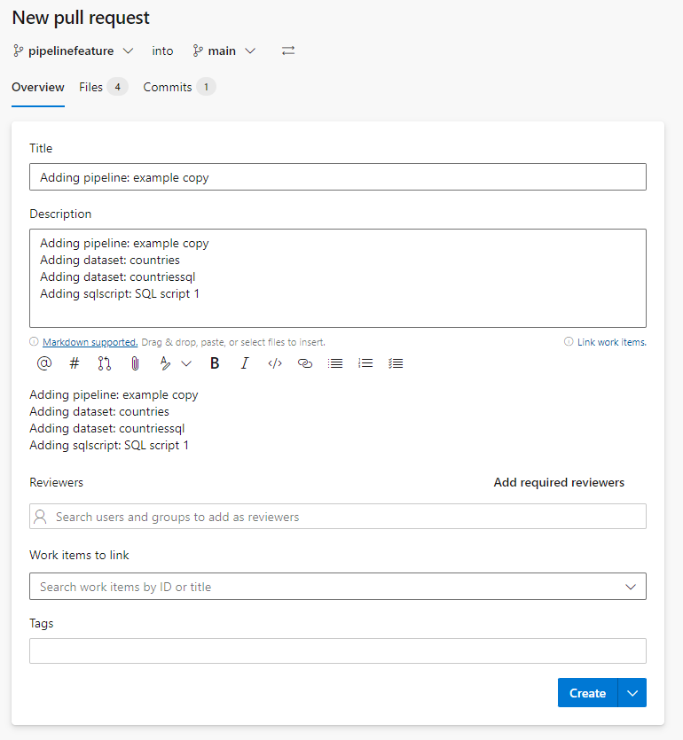

And in the screen that follows, click “Complete” –

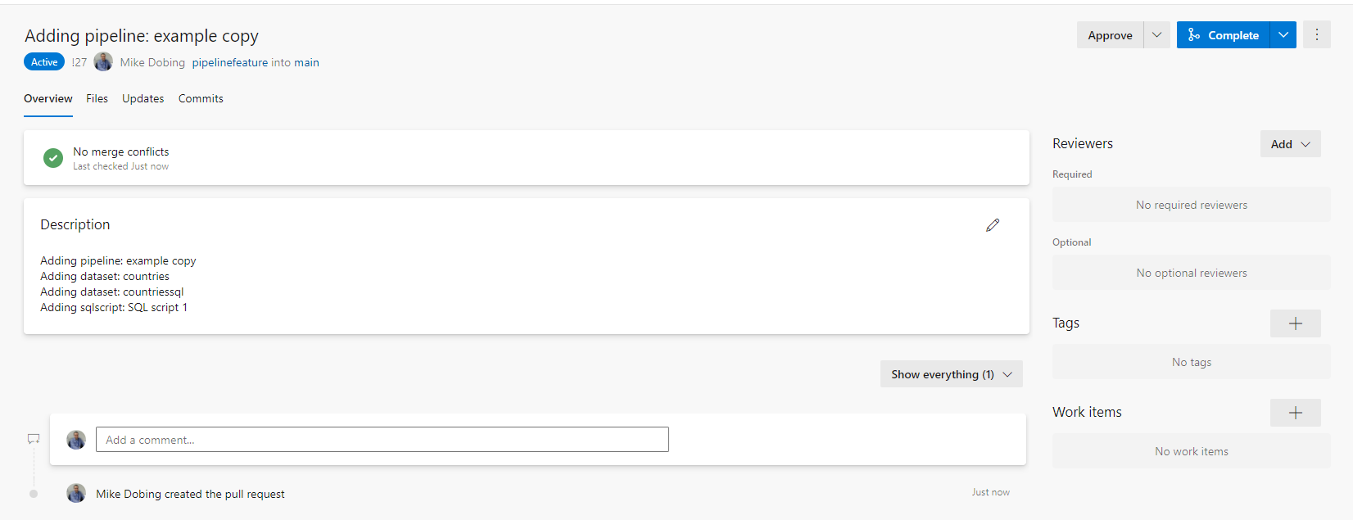

And finally, click Complete Merge –

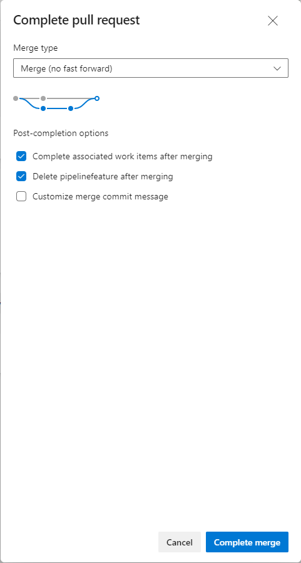

Your merge request back into main has now been completed –

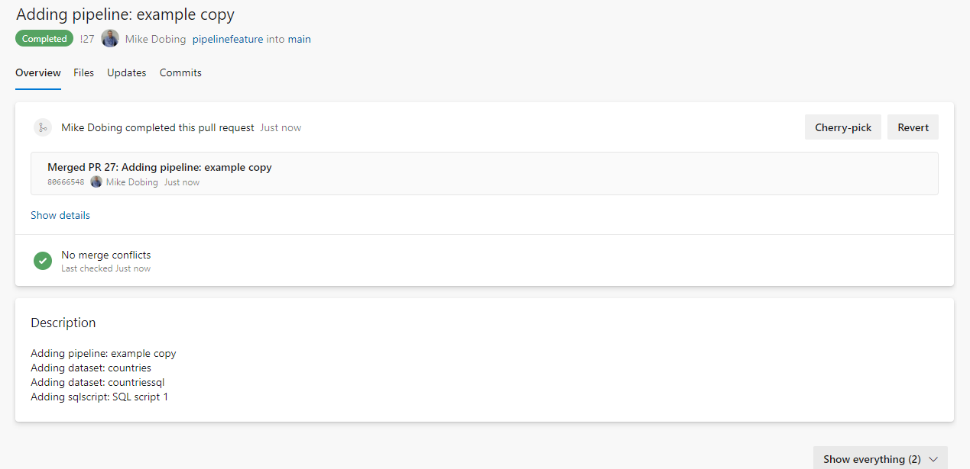

Finally in the Workspace, click on Publish to generate the artifacts

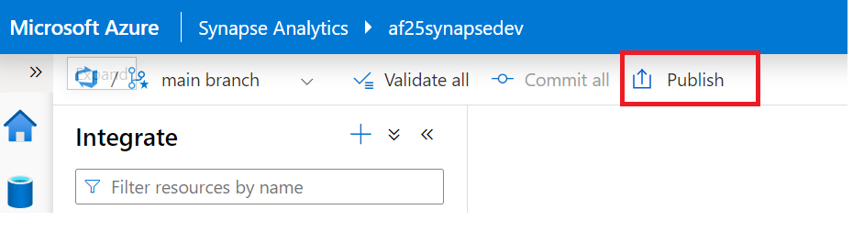

Exercise 6 has been completed

Exercise 7: Deploy Synapse workspace infrastructure for QA environment

Building on your skills from the last two modules regarding Synapse and Azure Devops, we need to promote the workspace before the Artifacts are taken over. in this exercise you will learn how to deploy the Development Synapse Workspace Infrastructure to a QA environment. You will create a build pipeline, a release pipeline and add permissions to your promoted workspace.

Tasks

1. Sign in to Azure portal

*Sign in* to Azure portal by clicking <https://portal.azure.com/> with your Azure account.

1. Create a resource group ‘rg-synapse-qa’

This step creates a new QA Resource group for our worksce to be deployed into. Navigate to Resource Groups > click Create >

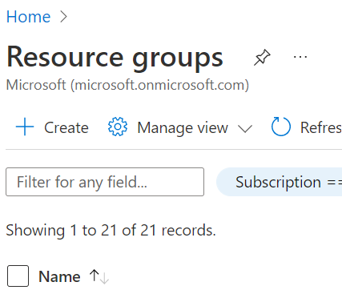Call the Resource Group **‘rg-synapse-qa’**

1. Create a service connection from Azure DevOps.

You need to create a Service connection to external and remote services for executing tasks in an Azure Devops job. Once you establish a connection, you can view, edit, and add security to the service connection



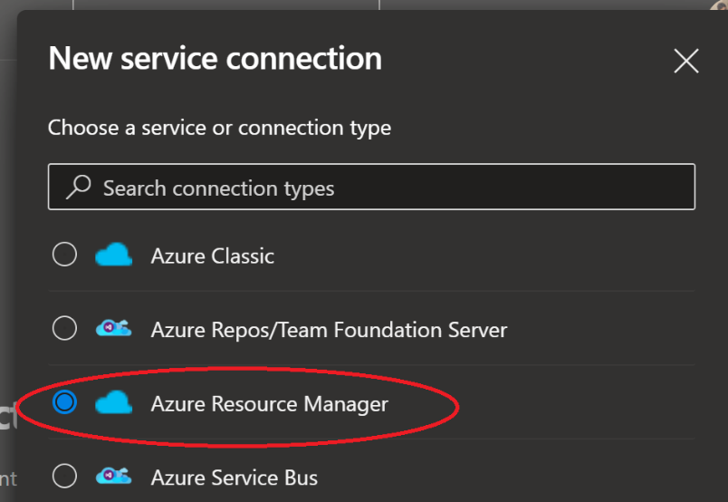

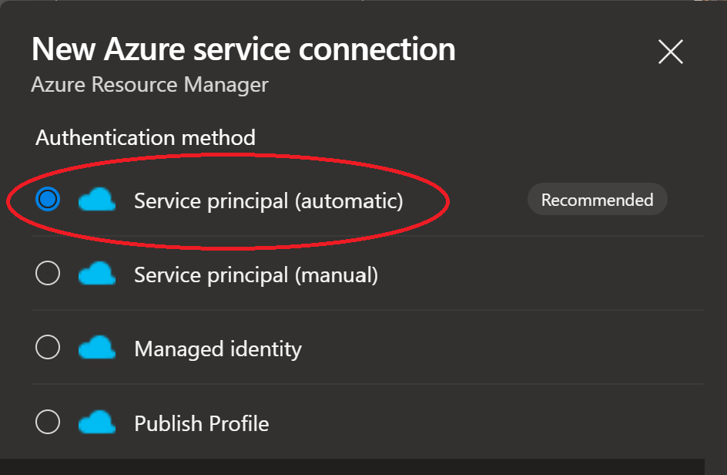

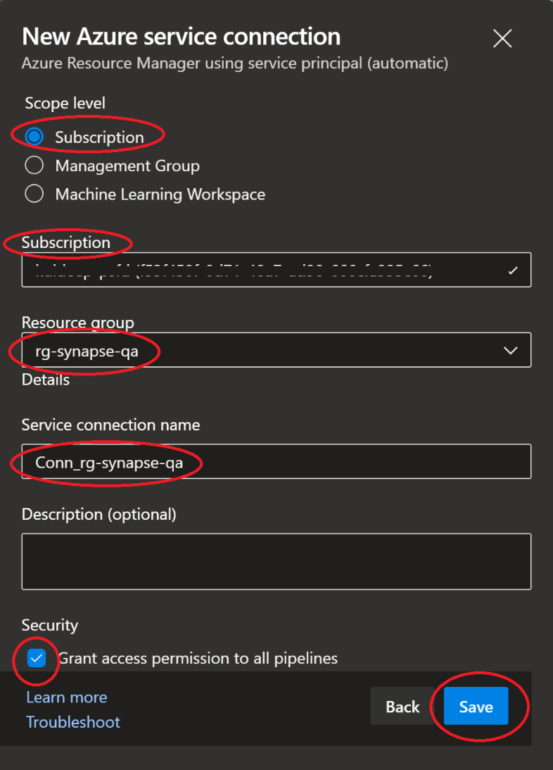

1. Add permissions for Service Connection

Once you have created the service connection navigate to the newly created Service connection within the Azure Devops project > settings > service connections. Pick the QA service connection and manage service principals > access control > add role assignments> add the following permissions > User Access Control Administrator

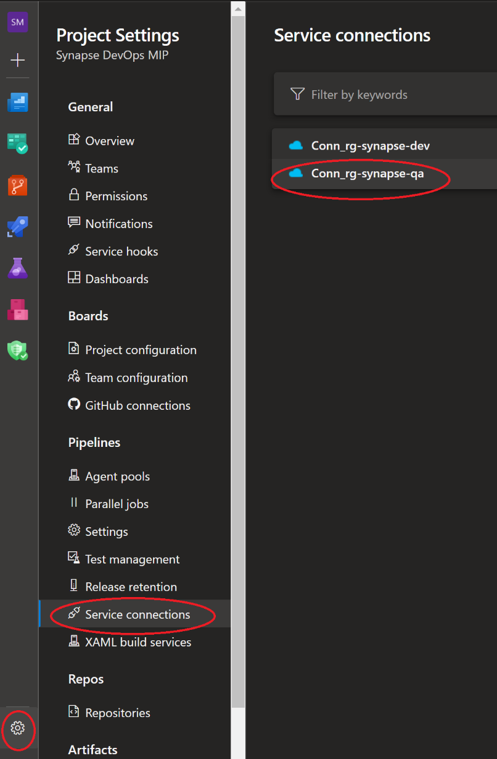

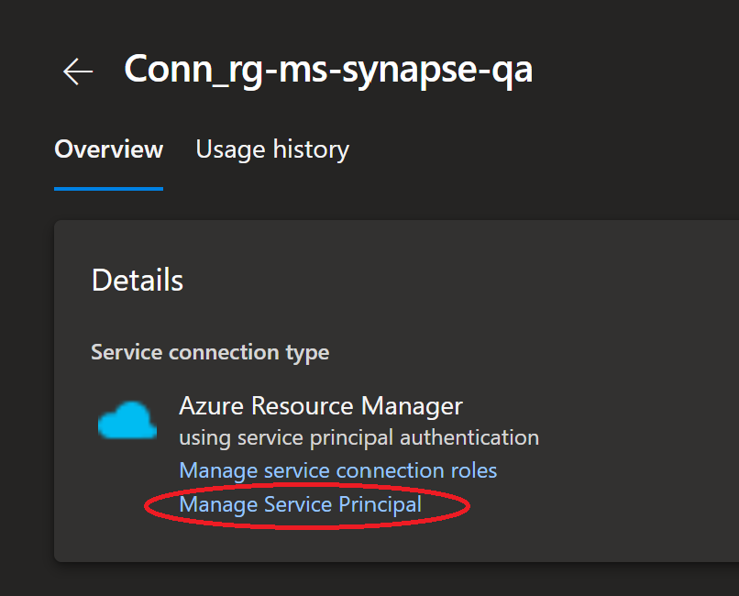



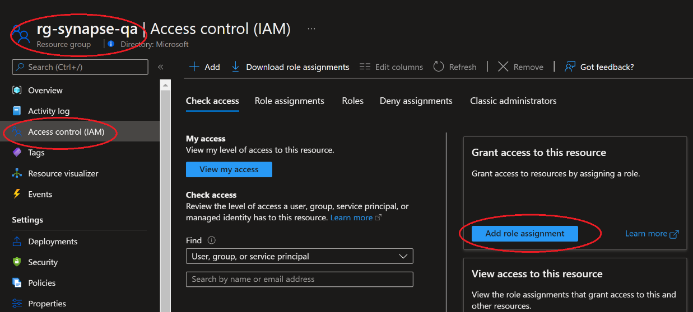

Navigate to your QA resource group ‘rg-synapse-qa’ and add Role assignments for ‘User Access Administrator’ role.

Select ‘User Access Administrator’ role and click next



On the members tab, Click ‘Add Members’ then search for the application name copied in above ‘Copy Display Name’ step.



Click ‘Review and Assign’ to add the permissions.

1. Create Build Pipeline

Select *Pipelines* from left navigation and click on ‘Create pipeline’.

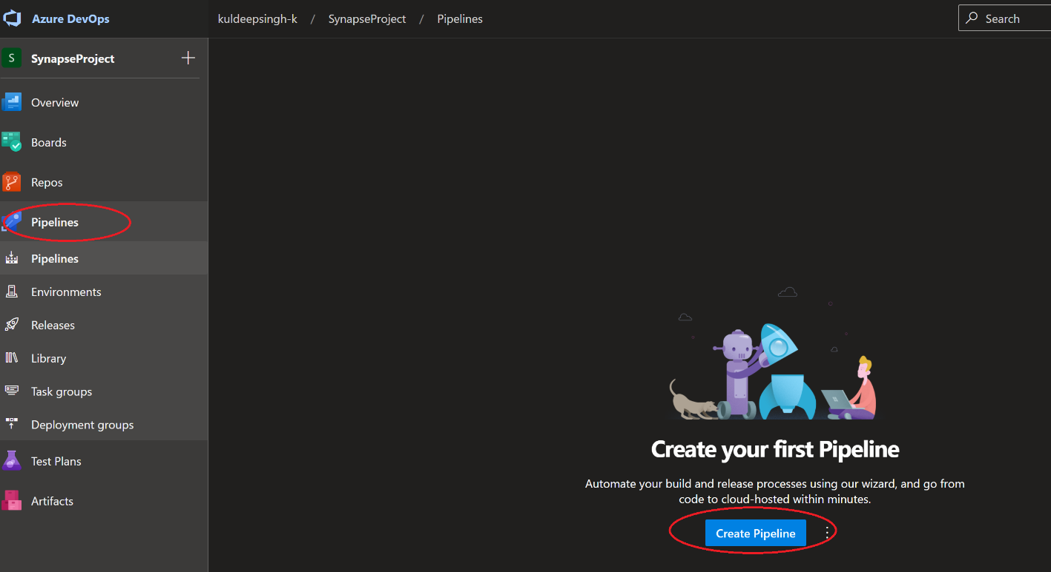

Select Azure Repos Git

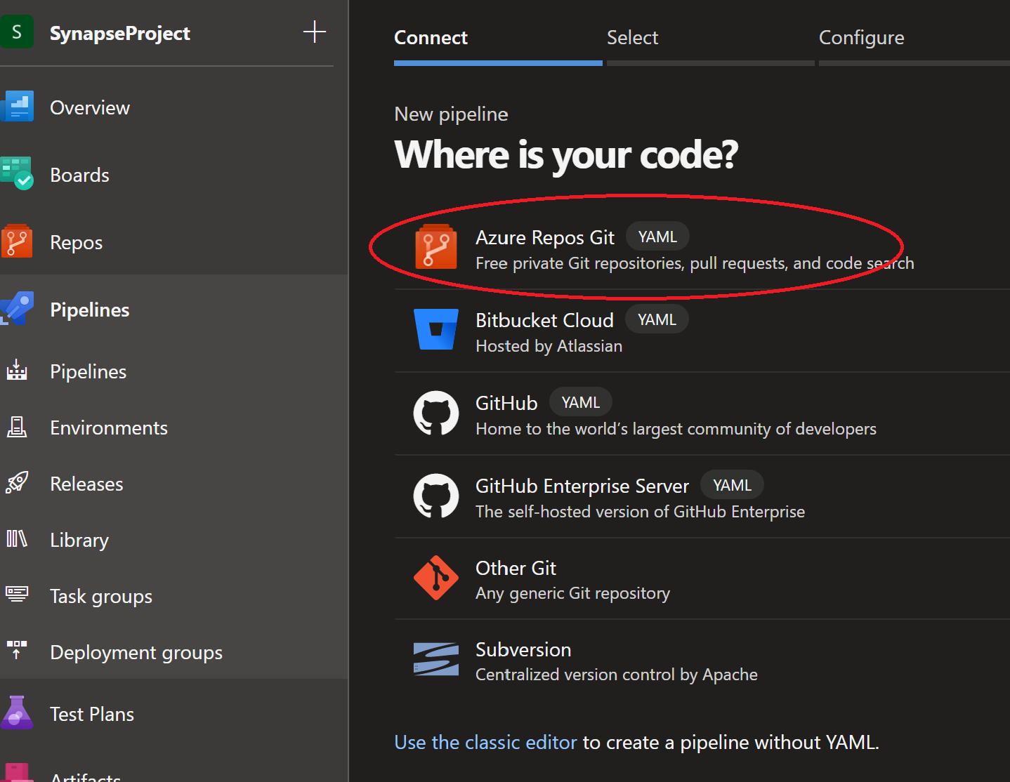

Select the ‘SynapseInfraRepo’

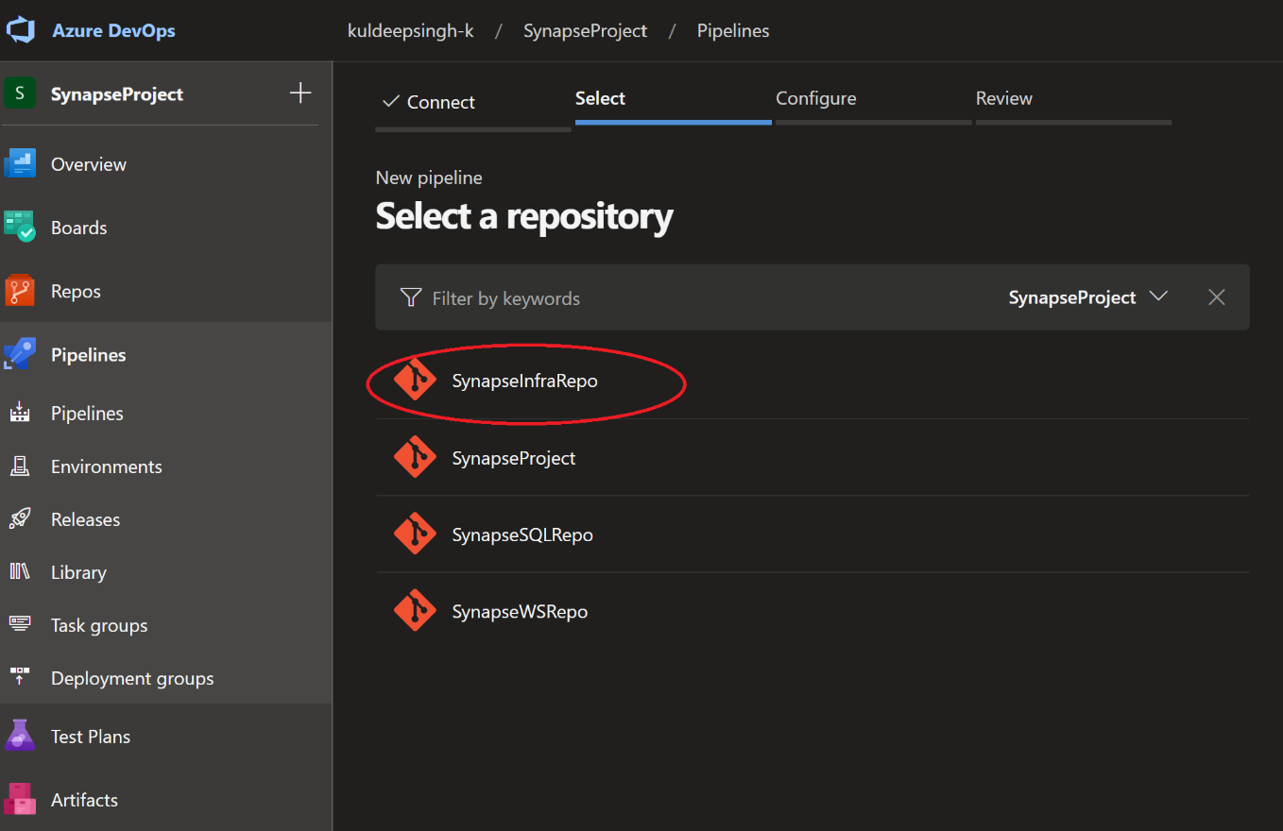

Select Existing Azure Pipelines YAML file

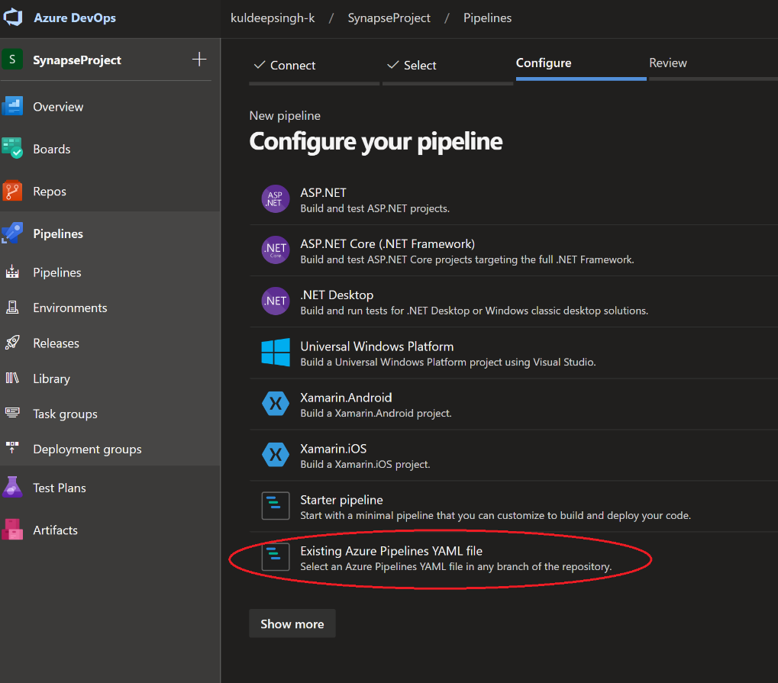

Select the *main* branch and path as ‘/SynapseInfraBuild.yml’. Click Continue.

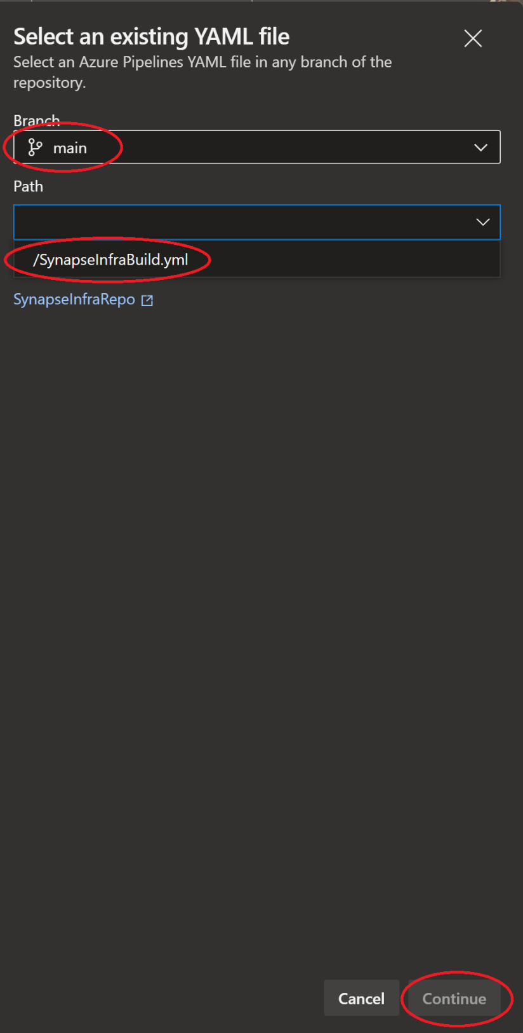

Click run to save and run the pipeline.

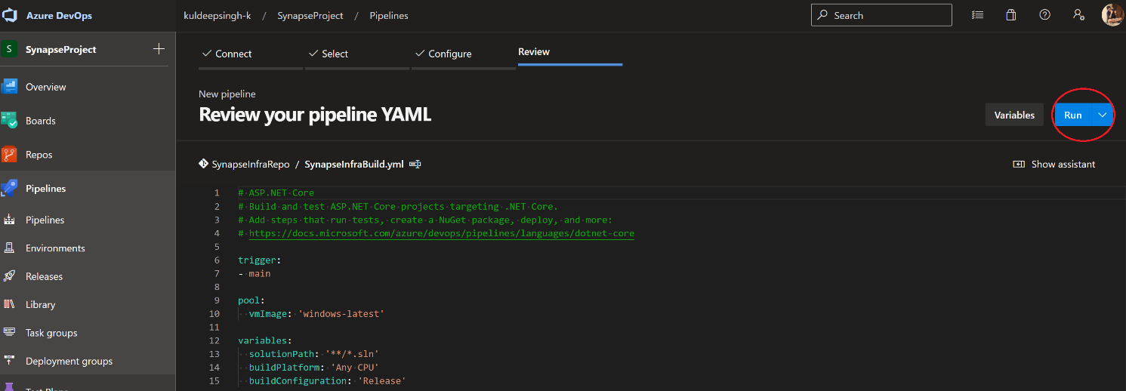

Go back to pipeline menu option from left navigation. Select pipeline ‘SynapseInfraRepo’ and rename it to ‘Synapse-Infra-Build’,

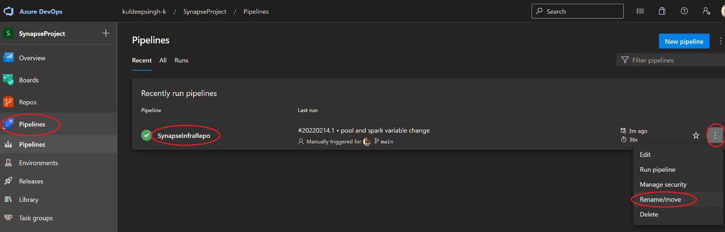

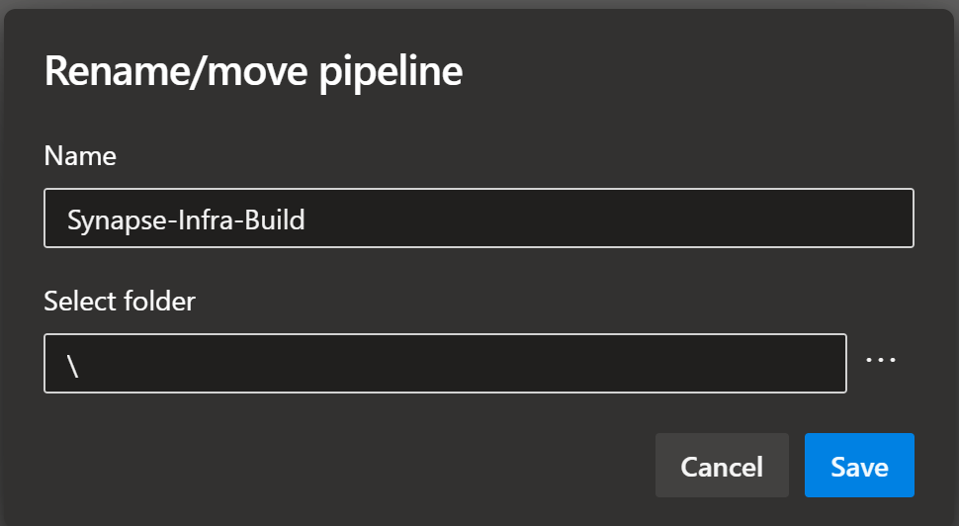

1. Create Release

From the left menu select *Pipelines* and click *Releases*. Click on ‘New Pipeline’

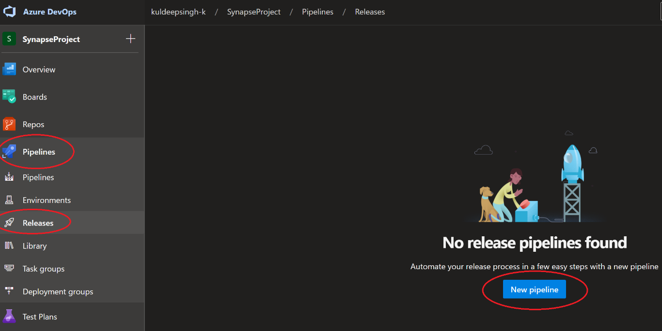

Select Empty job

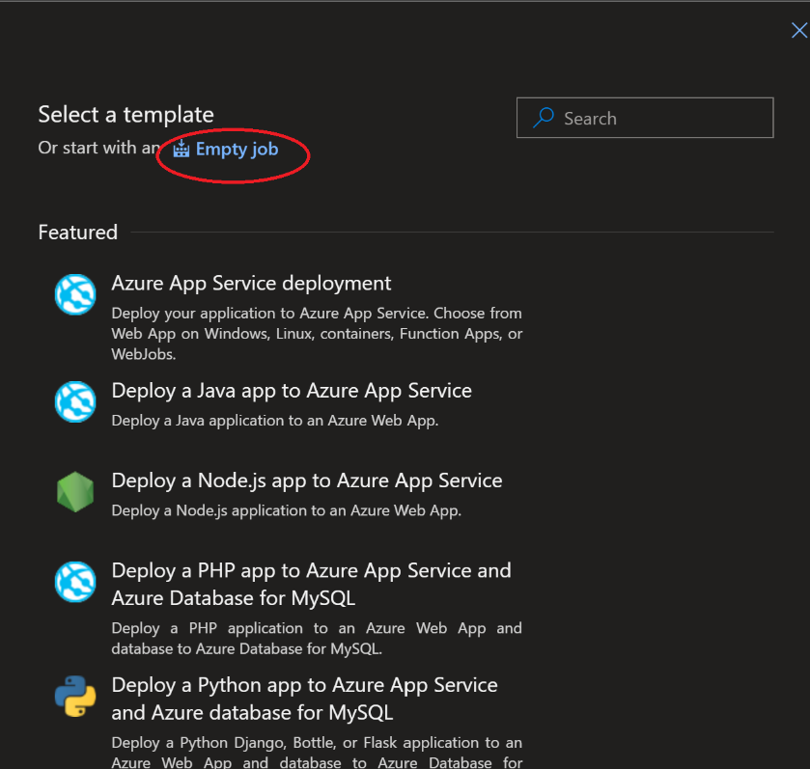

Name the pipeline as ‘synapse-Infra-Release’ and enter the Stage name as QA.

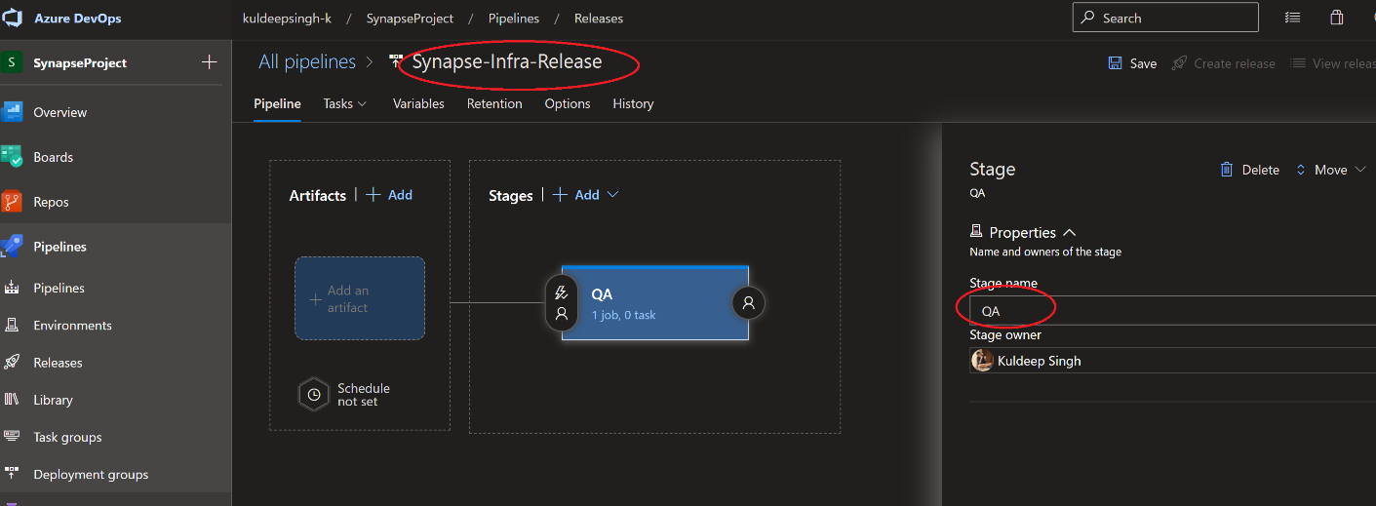

Add a new Artifact and click save after providing below values,

Project – ‘SynapseProject’

Source – ‘Synapse-Infra-Build’

Default Version –Latest

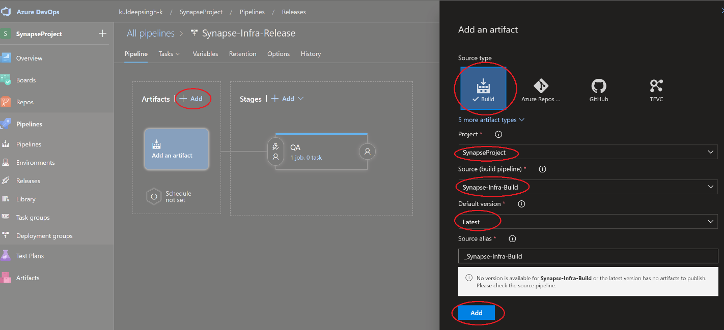

Click on ‘1 job, 0 task’ under QA stage

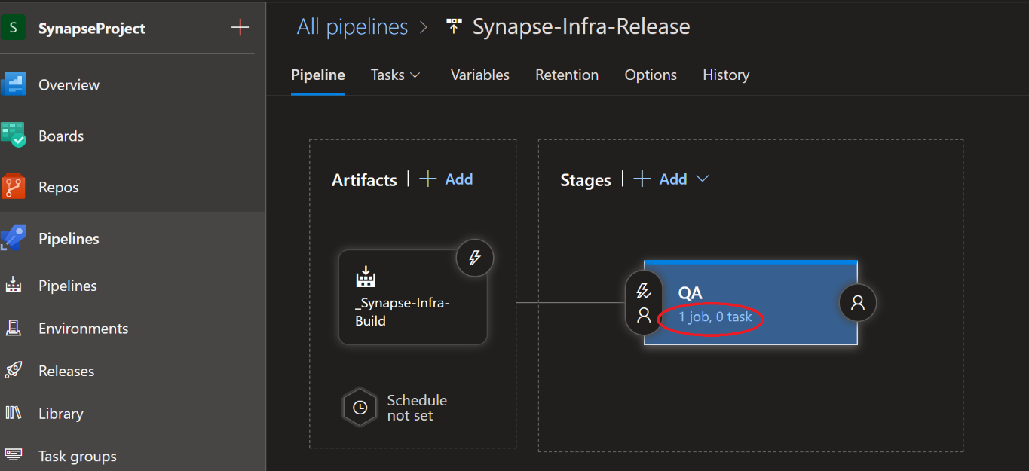

Add a ‘Azure PowerShell’ task to the Agent Job.

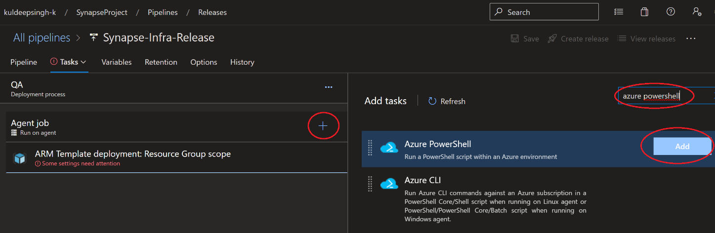

Select newly added ‘Azure PowerShell’ task and configure as below:

* + DisplayName: *Azure PowerShell script: CheckStorage Account*
  + Azure Subscription: ‘*Conn_rg-synapse-qa*’ (This is service connection created in Exercise 7, Task 3)
  + Script Type: *Inline Script*
  + Inline Script:

*$storageName= "$(uniqueString)" + 'storageqa'*

*## Get storage account*

*$sa = get-AzResource -name $storageName -ResourceType 'Microsoft.Storage/storageAccounts'*

*if($sa -eq $null)*

*{*

*echo "##vso[task.setvariable variable=createNewSA]true"*

*}*

*else*

*{*

*echo "##vso[task.setvariable variable=createNewSA]false"*

*}*

* + Preferred Azure Powershell version: *3.1.0*
* Click Save

Add an ‘ARM template Deployment’ task to the Agent Job.

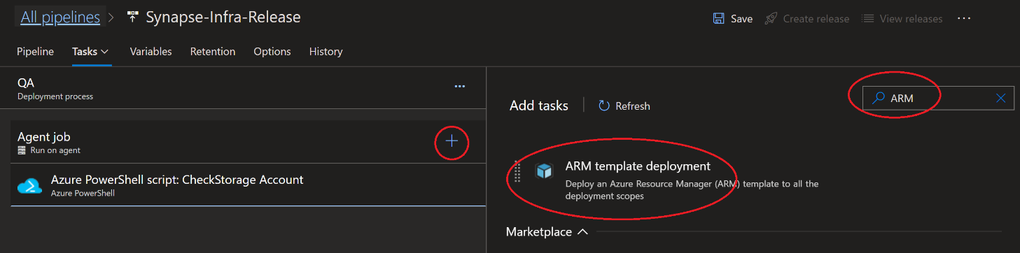

Select newly added ‘ARM template Deployment’ task and configure as below:

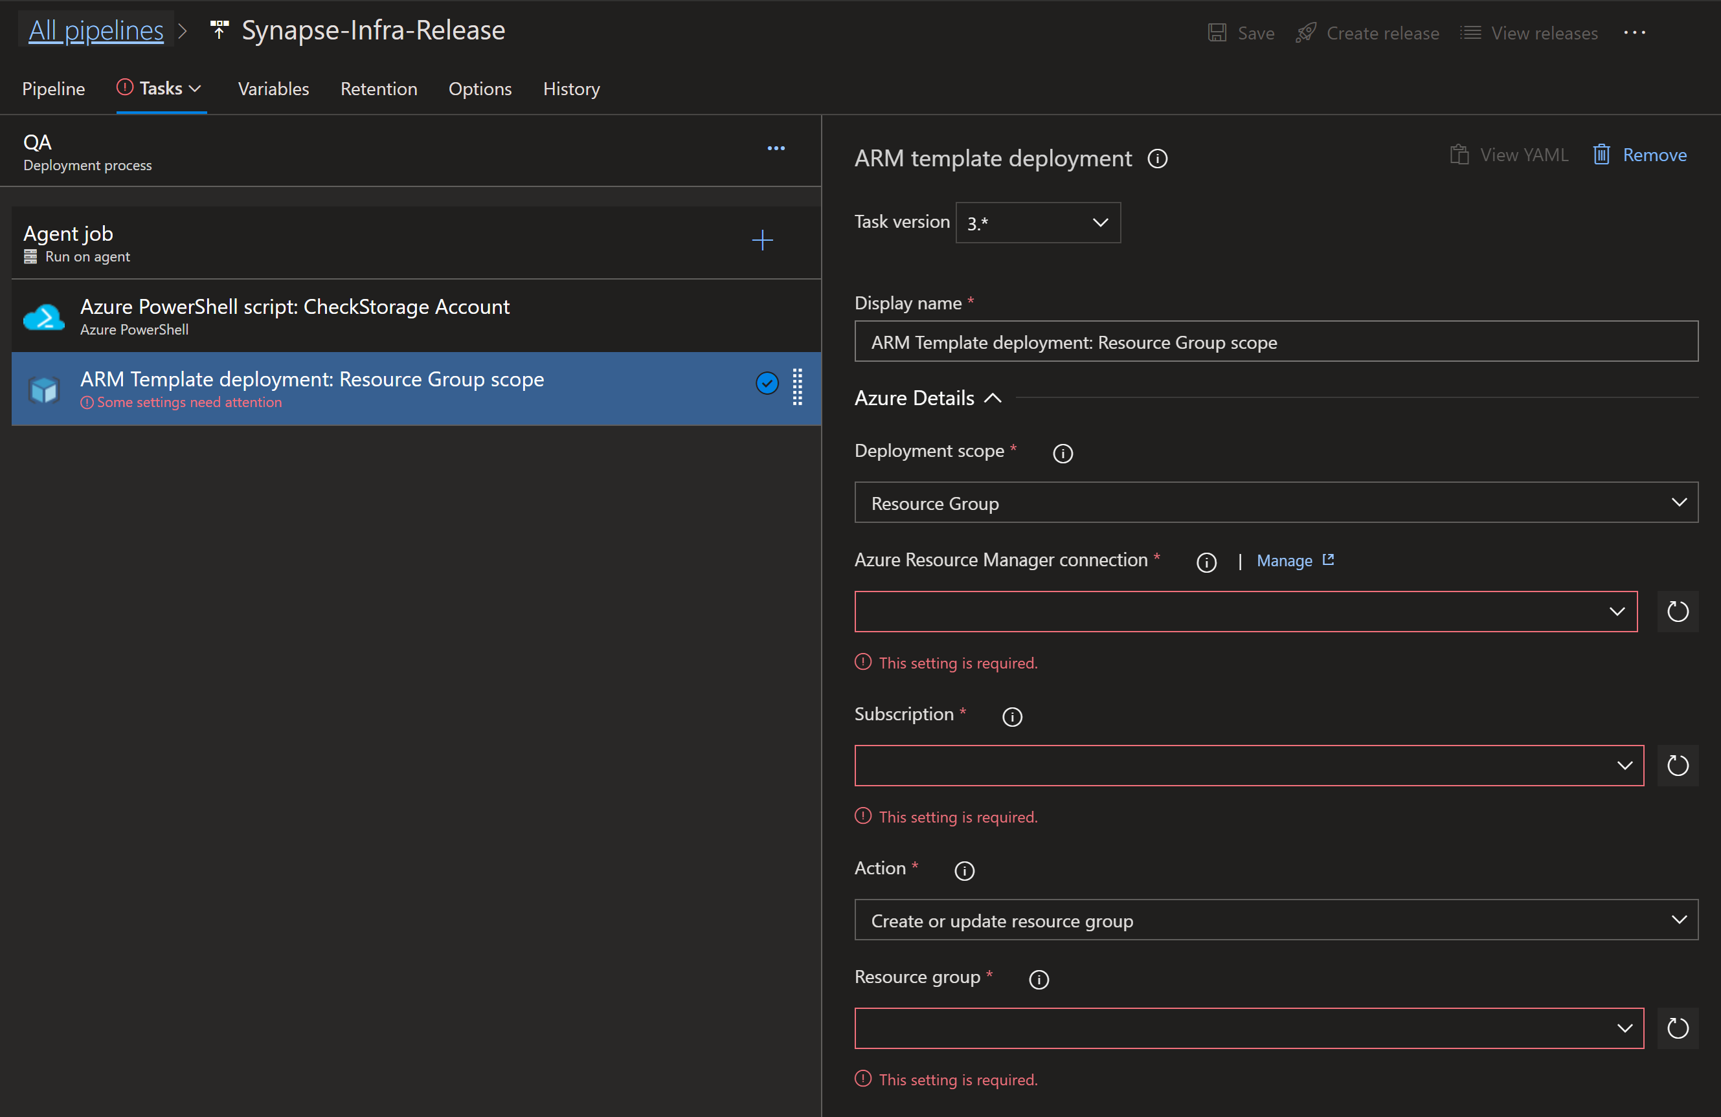

Display Name – Keep the default (ARM Template deployment: Resource Group scope)

Deployment Scope – Resource Group

Azure Resource Manager connection – ‘*Conn_rg-synapse-qa*’ (This is service connection created in Exercise 7, Task 3)

Subscription - Select your subscription.

Action – Create or update resource group.

Resource Group – rg-synapse-qa

Location- Choose the closest region.

Template path : click on the ellipses and navigate to where the template json files are held. Choose the Template and then the Template parameters

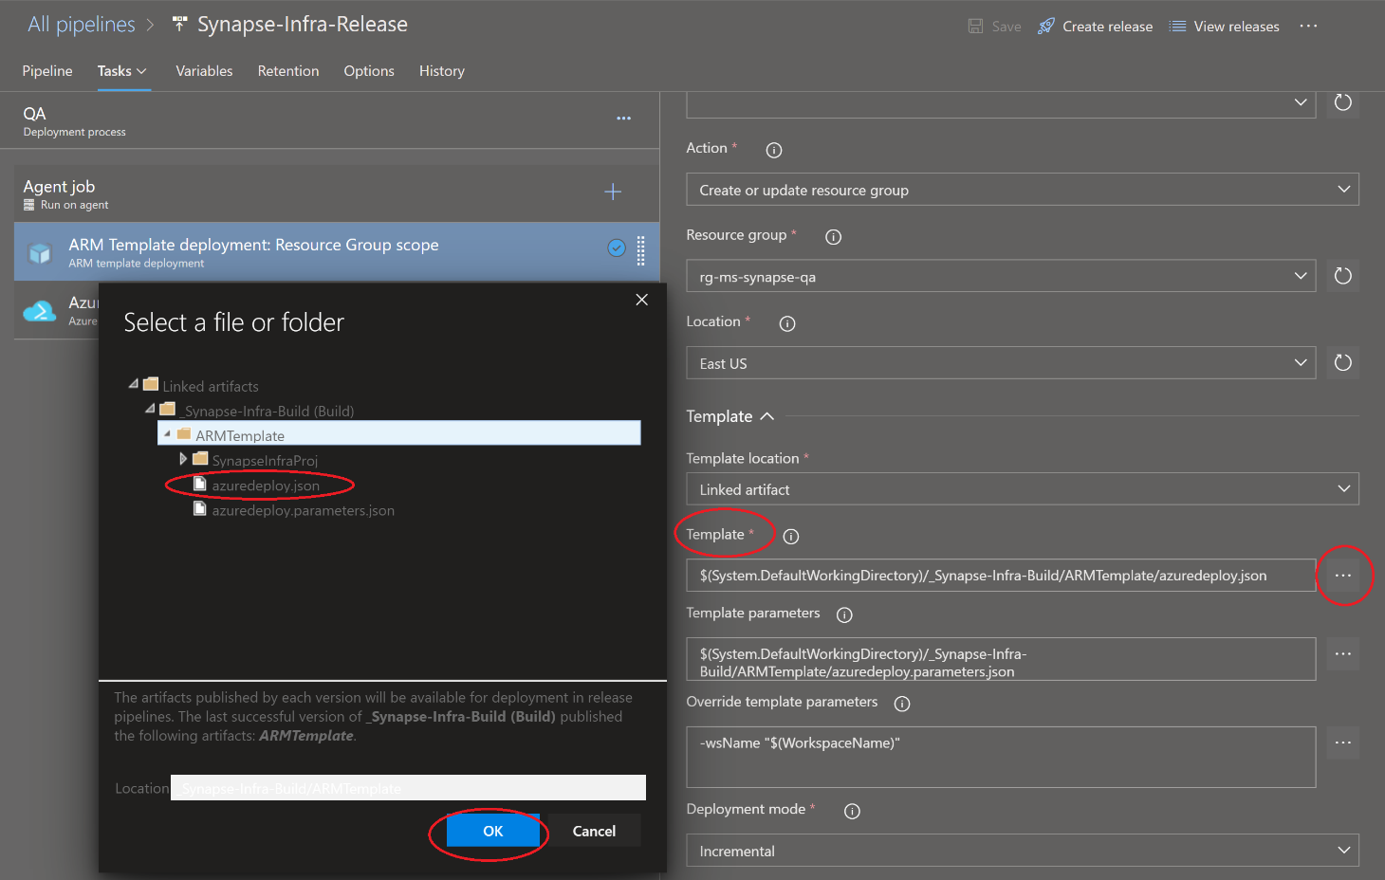

Override template parameters: *-uniqueString $(uniqueString) -userObjectId $(userObjectId) -setWorkspaceIdentityRbacOnStorageAccount $(createNewSA)*

Deployment Mode: *Incremental*

Add a ‘Azure PowerShell’ task to the same Agent job

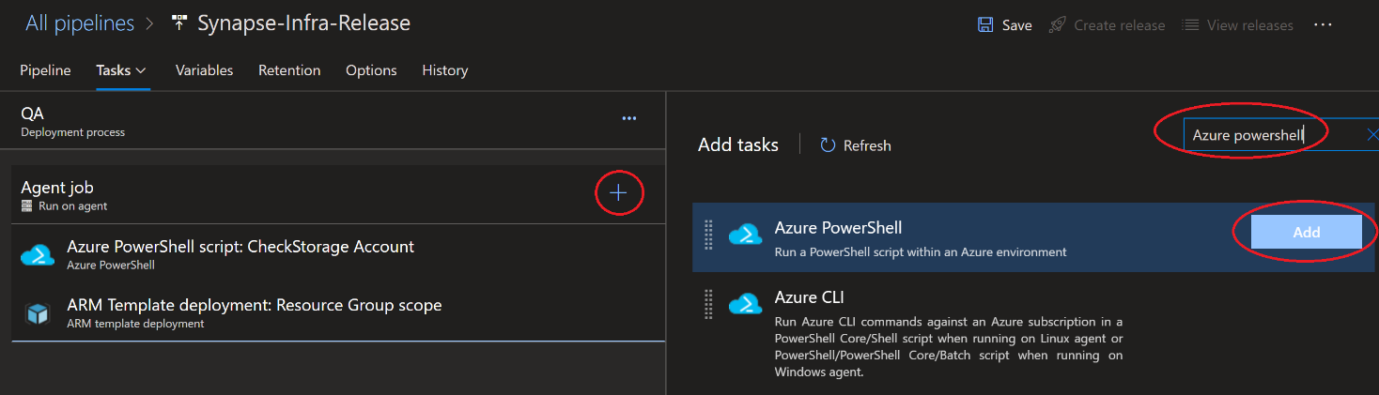

Select newly added ‘Azure PowerShell’ task and configure as below:

* + DisplayName: *Azure PowerShell script: WorkspacePermissions*
  + Azure Subscription: ‘*Conn_rg-synapse-qa*’ (This is service connection created in Exercise 7, Task 3)
  + Script Type: *Inline Script*
  + Inline Script:

*##Required for azure devops initial deployment*

*Install-Module Az.Synapse -RequiredVersion 0.7.0 -Scope CurrentUser -Force -AllowClobber*

*##ObjectID is for bballasw_WSAdmins*

*$WorkspaceName = "$(uniqueString)" + '-synapse-qa'*

*New-AzSynapseRoleAssignment -WorkspaceName $WorkspaceName -RoleDefinitionName "Workspace Admin" -ObjectID "$(UserObjectId)"*

* + Preferred Azure Powershell version: *3.1.0*

It should look like this once configured:

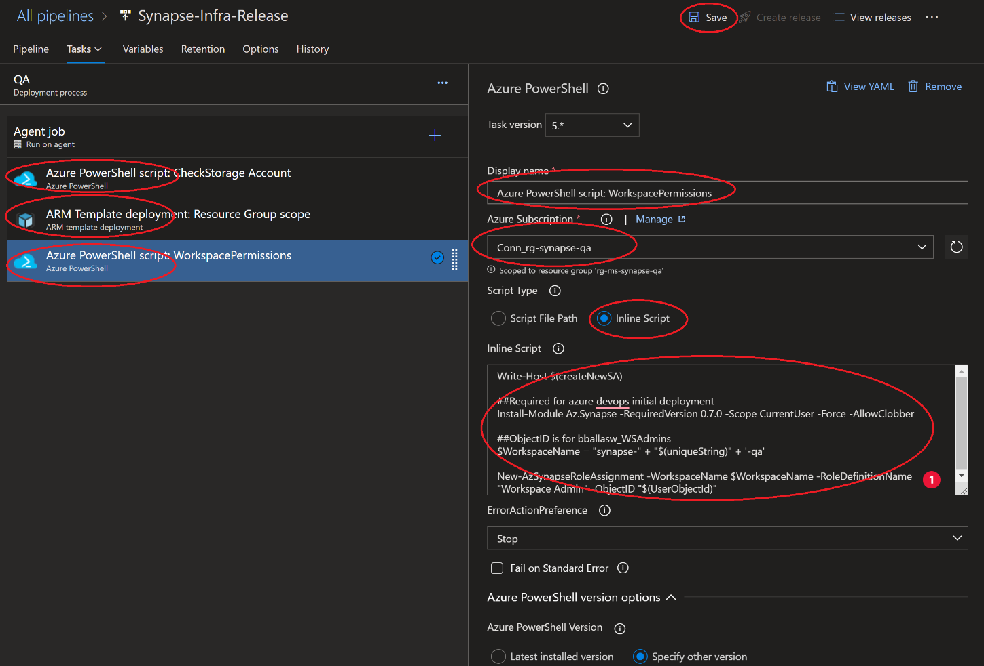

After configuring all the tasks click ‘Save’ on top right of the screen.

Add pipeline variables as below:

|  |  |  |  |
| --- | --- | --- | --- |
| Name | Value | Scope | Settable at release time |
| createNewSA | true | release |  |
| uniqueString | <UNIQUESTRING> | release | check |
| UserObjectId | <Object Id> for current user | release |  |

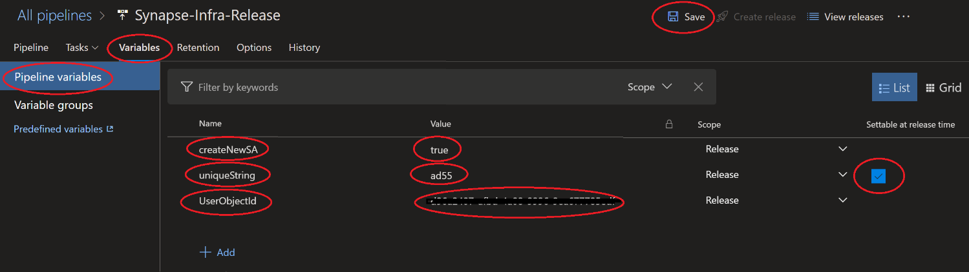

Click Save

Verify pipeline and ‘Create Release’

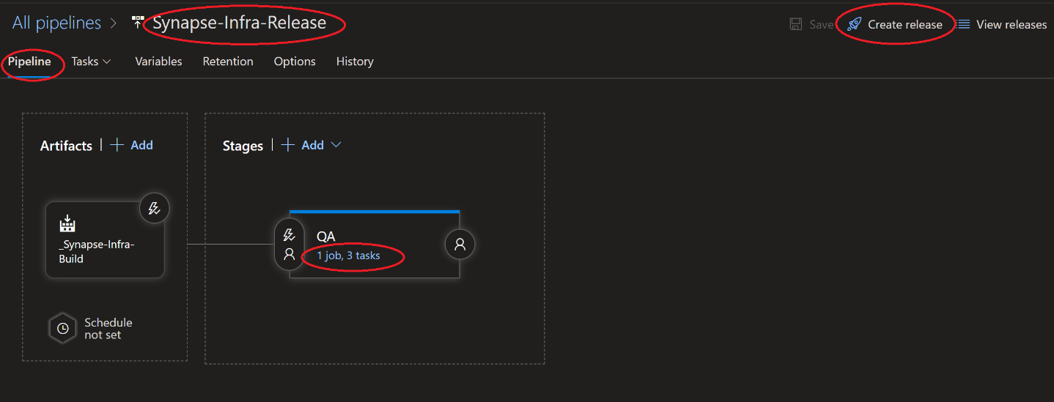

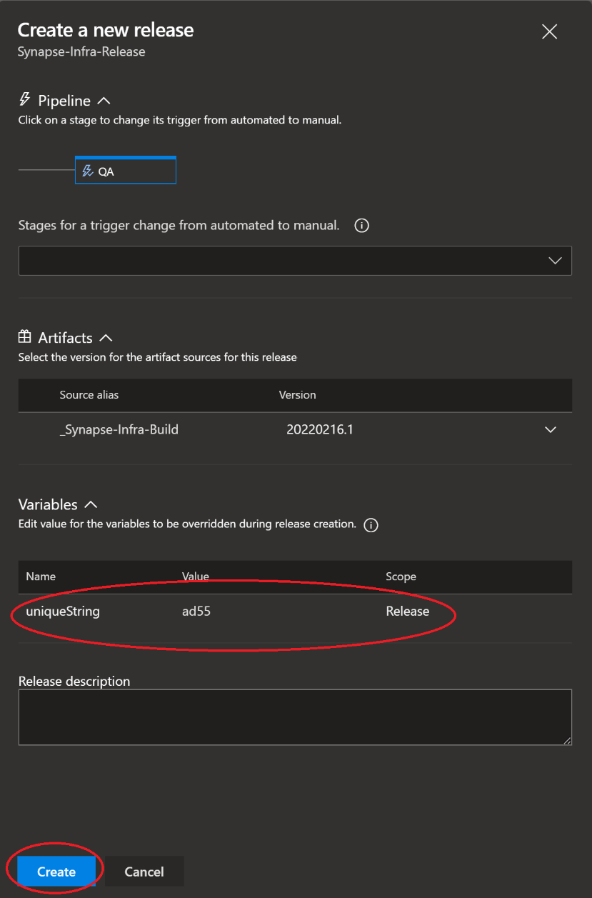

Verify the status of release:

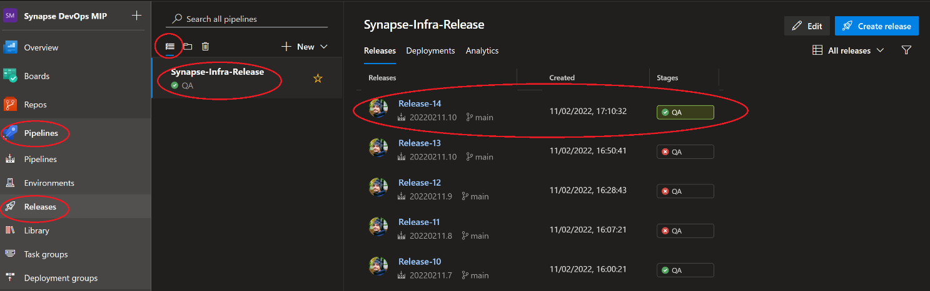

Exercise 7 has been completed

Exercise 8: Dedicated SQL Pool deployment using Azure DevOps

This exercise shows how to promote your SQL dedicated pool to a QA environment

Tasks

1. Sign in Azure DevOps

S*ign in* Azure DevOps by clicking <https://dev.azure.com/> with your Azure DevOps account.

1. Create Build Pipeline

Navigate to ‘SynapseProject’. Select *Pipelines* from left navigation and click on ‘Create pipeline’.



Select Azure Repos Git



Select the ‘SynapseSQLRepo’

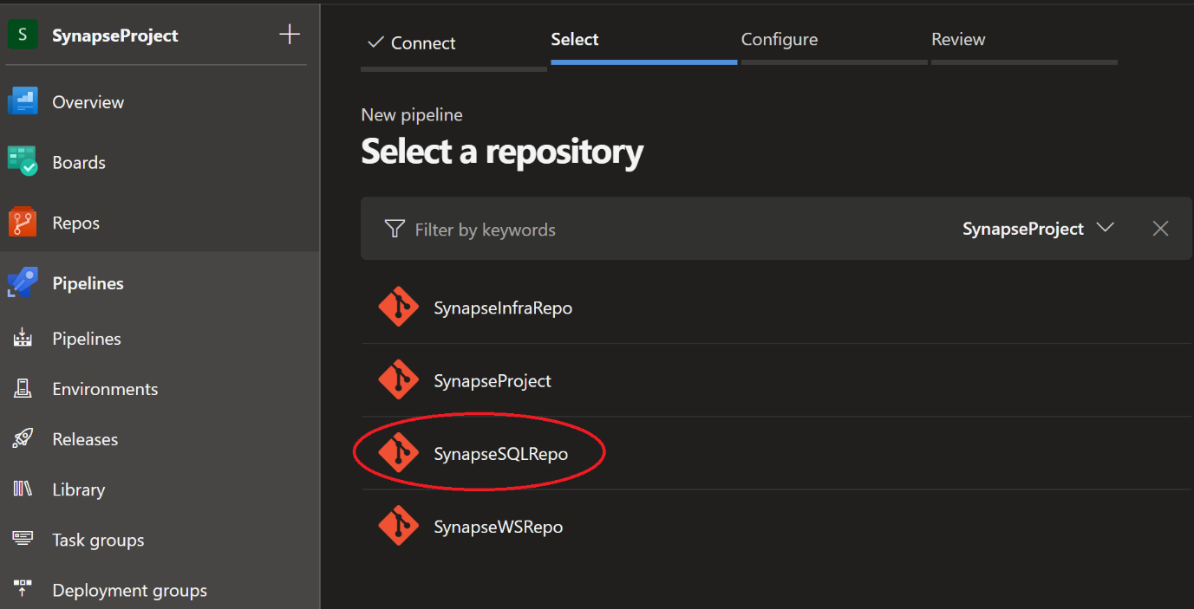

Select Existing Azure Pipelines YAML file



Select the *main* branch and path as ‘/SynapseSQLBuild.yml’. Click Continue.

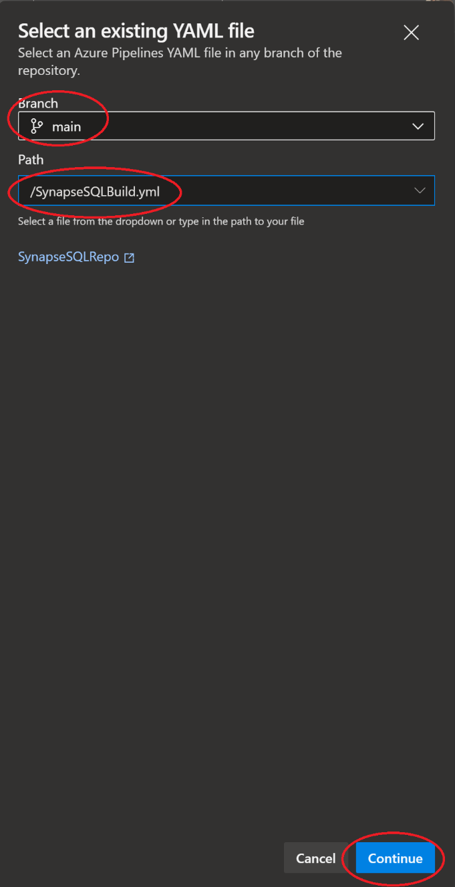

Click run to save and run the pipeline.



Go back to pipeline menu option from left navigation. Select pipeline ‘SynapseSQLRepo’ and rename it to ‘Synapse-SQL-Build’,

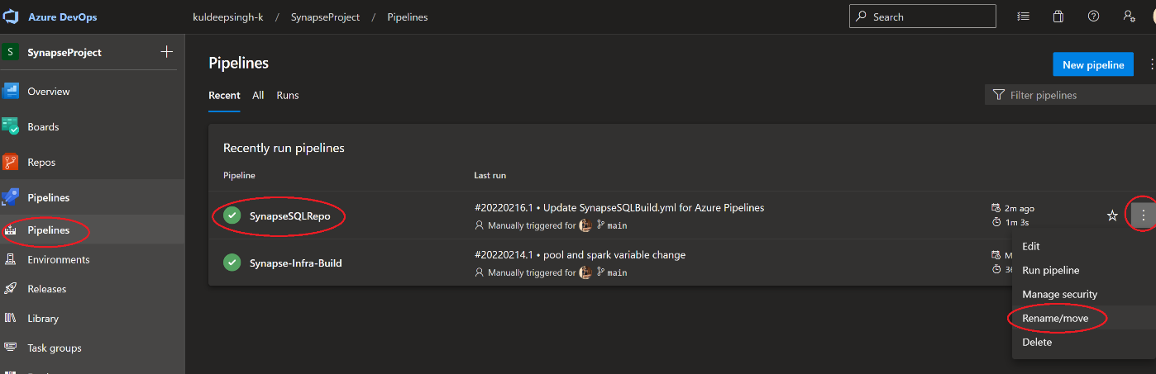

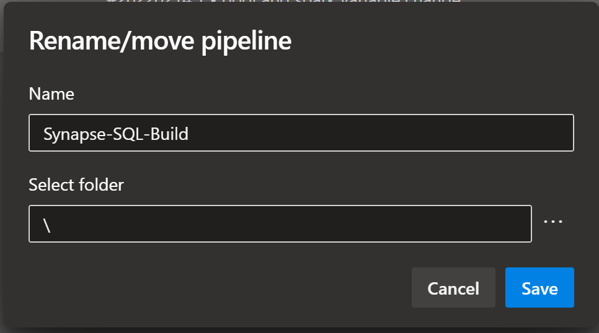

1. Create Release Pipeline

Navigate to ‘SynapseProject’. Select Releases under the Pipelines from left navigation and click on ‘Create release’.

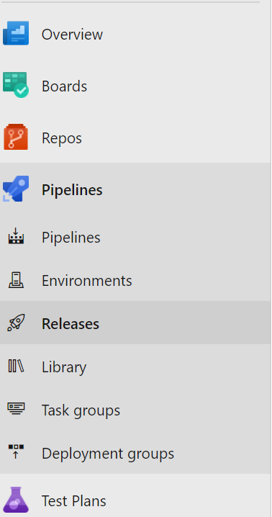

1. Click on New pipeline and select and Empty Job. On Stage give the name of the environment you want to deploy, for example Dev
2. Click on Add Artifact and select Build.

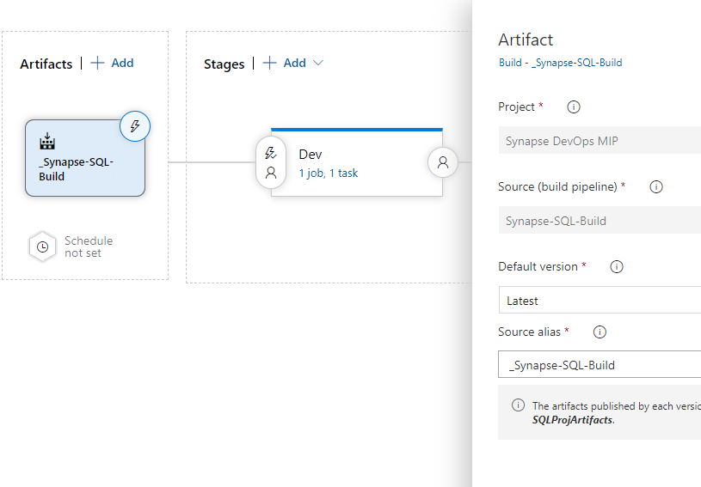

**IMPORTANT** If you build was successfully, you will notice the white spaces will get updated automatically.

1. Add a new Stage , rename the stage as Dev

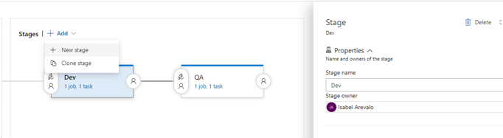

1. Click Under the "Dev" Task and add an Azure SQL DacPacTask and fill following information

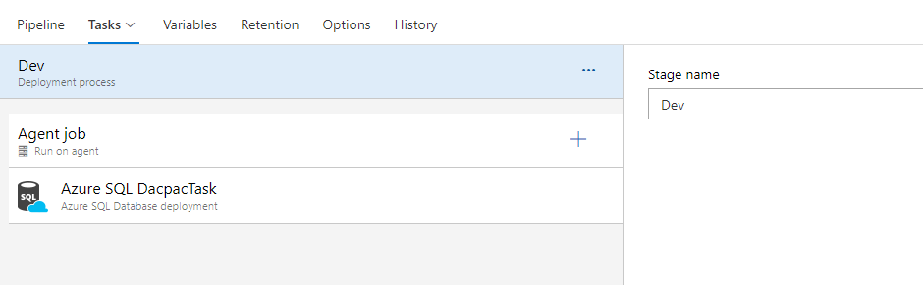

        Azure Subscription = select your subscription

        Authentication Type = SQL Server Authentication

        Azure SQL Server = Name of the dedicated pool created in exercise 2

        Database = Name of the database created in exercise 2

        DACPAC File = This should the dacpac build under the bin folder . The screen should look like this:-

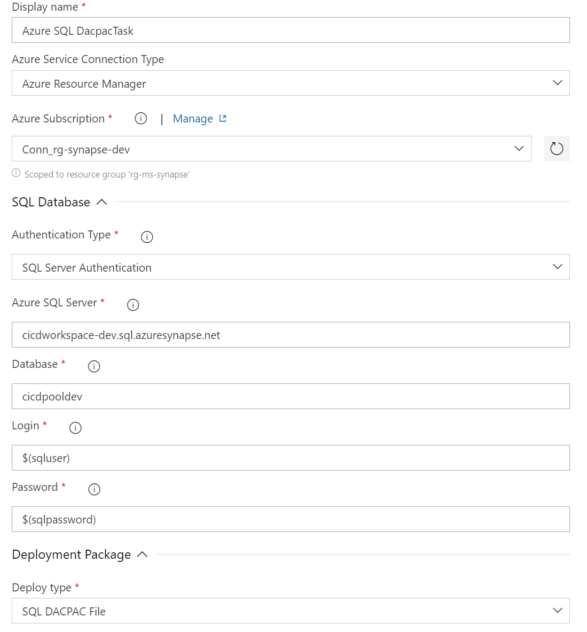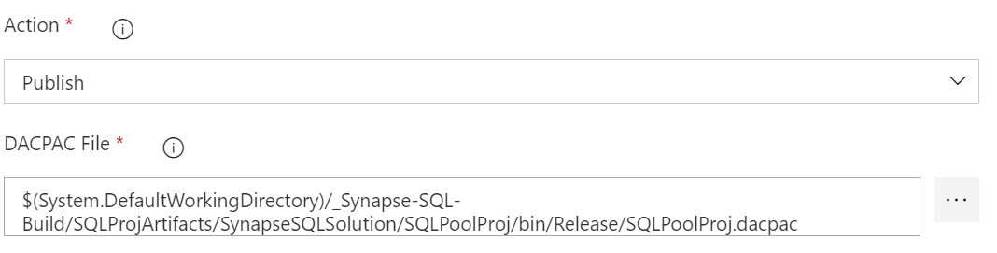

Go to **Variables** and create two variables to hold the values for the sqluser variable and Password variable used (these were set when you created the Workspace in Exercise 1)

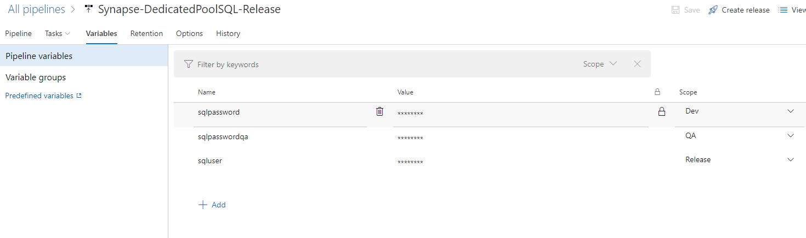

**Note**:- please make sure you select the right scope for your environment, in this sample you will notice we have sqluser and its scope set to Release this is because, the same user is share to log into Dev and QA.

Click on Save and the create a Release

Note:- If you want to deploy the changes to QA you can clone the QA Step and update the values to the equivalent in QA. In the variables screenshot above you can see there is a *sqlpasswordqa* that you can replace into your cloned QA stage

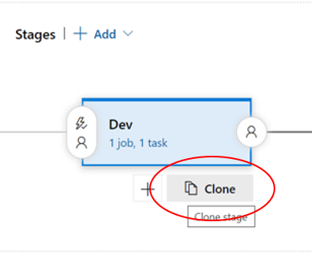 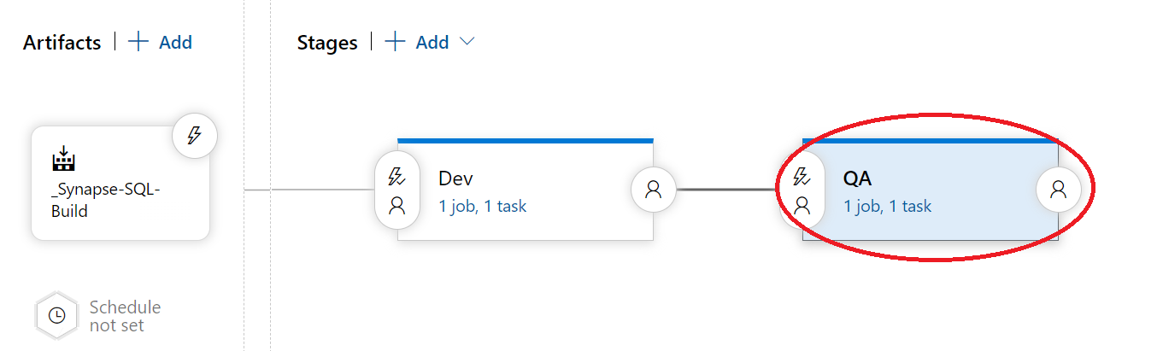

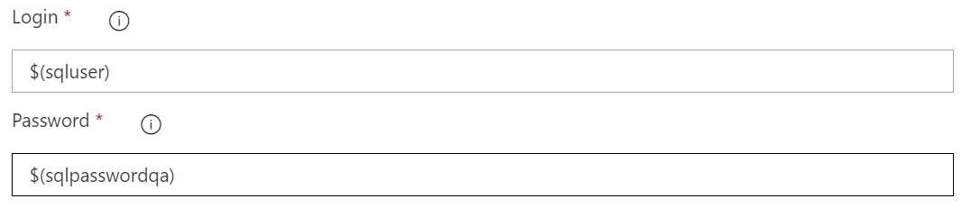

1. Test Release.

Go to Release and click on create release

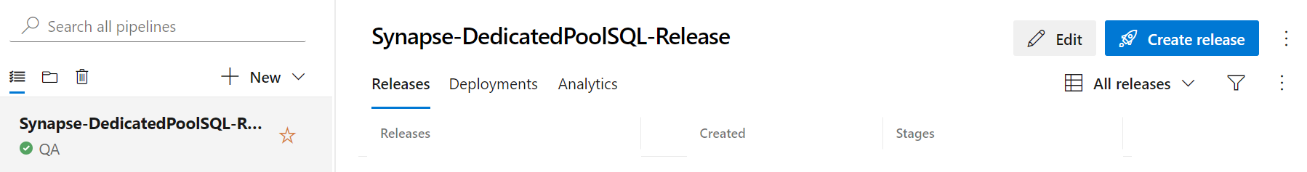

Add a description and click on create

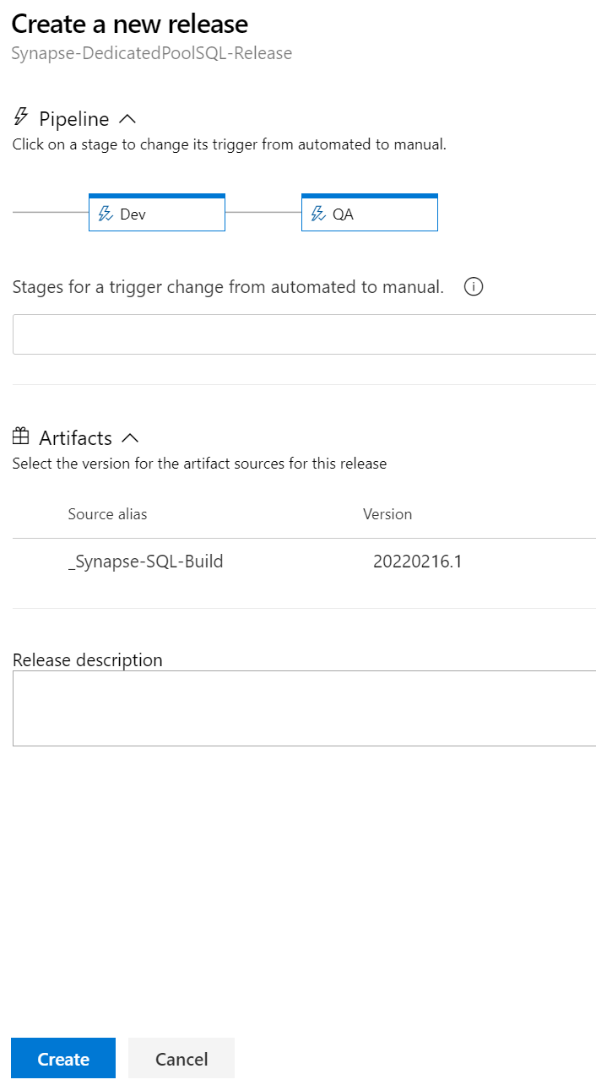

Once the release finishes, you will notice a green box, this means the release completed successfully

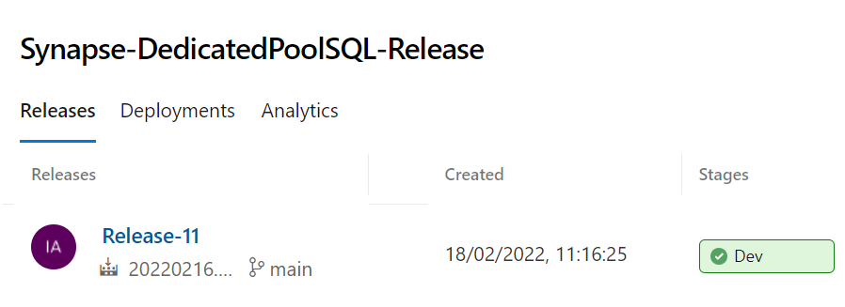

Go to your dedicated pool and refresh it, you should see new table called DimProductDemo

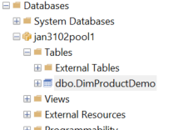

Exercise 8 has been completed

Exercise 9: Serverless SQL deployment using Azure DevOps

This exercise shows how to promote

Tasks

1. Create Release Pipeline

Navigate to ‘SynapseProject’. Select Releases under the Pipelines from left navigation and click on ‘Create release’.



1. 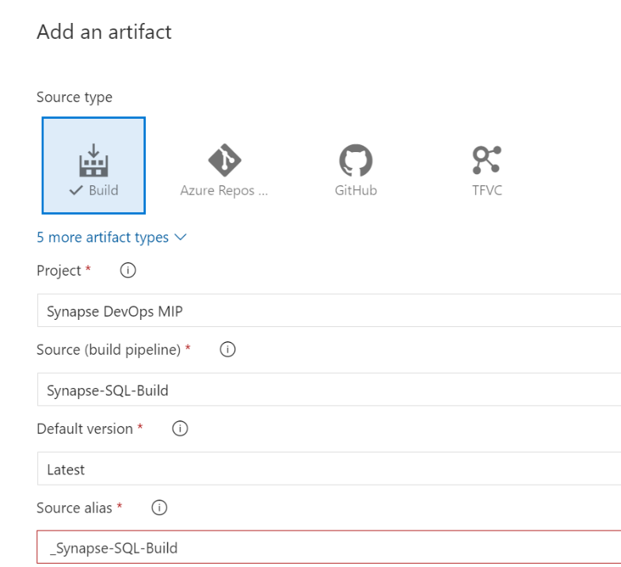Click on New pipeline and select and Empty Job. On Stage give the name of the environment you want to deploy, for example QA

Click on Add Artifact, select Build, and select the Synapse SQL Build

1. Go to Stage 1 and click on the task (You can rename the stage as QA)

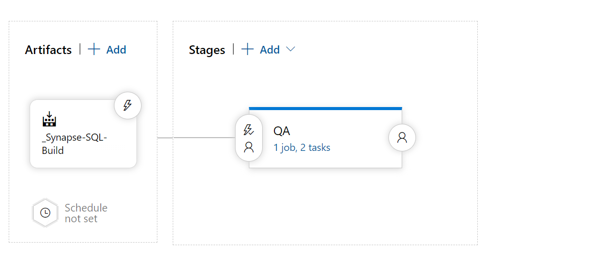

1. Click on the + and search for Azure SQL Database Deployment task

For this exercise we will be using the SQL Server Authentication and the Login and Password will be held on the Variables.

1. Go to variables tab and create two variables one will be used to hold the value of the SQL account and the other the password. Make sure you hide the values. It should look like

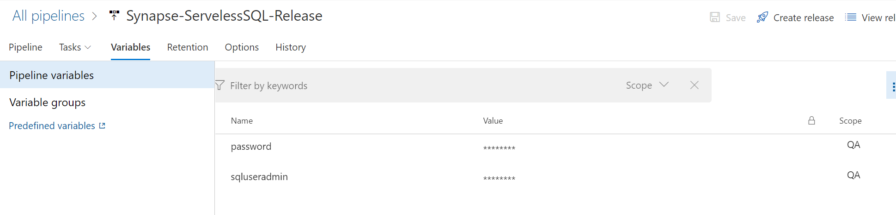

1. Fill the values from the Azure SQL Database task. For the database, use “master”, for the Login and Password, make sure you use this structure $(variablename)

Select Inline SQL Script in the Deploy Type and use this sql script

*IF NOT EXISTS(SELECT * FROM sys.databases WHERE name = 'aaduser')*

*CREATE DATABASE [aaduser]*

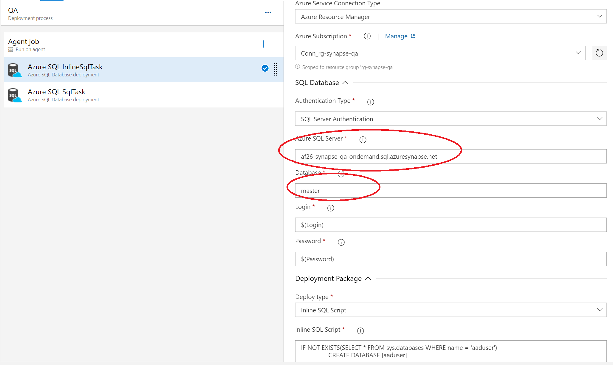

1. Add other Azure SQL Database deployment. We will be using to call the script from the repo to deploy the external table. Select SQL Script File for the Deploy Type and navigate to where you can find the sql script.

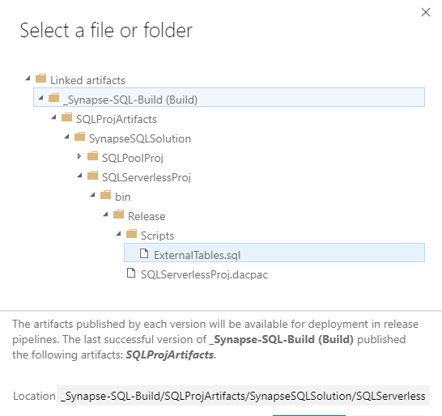

Note:- If you have multiples files you can always use *.sql at the end of the sql script

$(System.DefaultWorkingDirectory)/_Synapse-SQL-Build/SQLProjArtifacts/SynapseSQLSolution/SQLServerlessProj/bin/Release/Scripts/*.sql

Use the variables as we did in the previous step and the database name in this case will be adduser

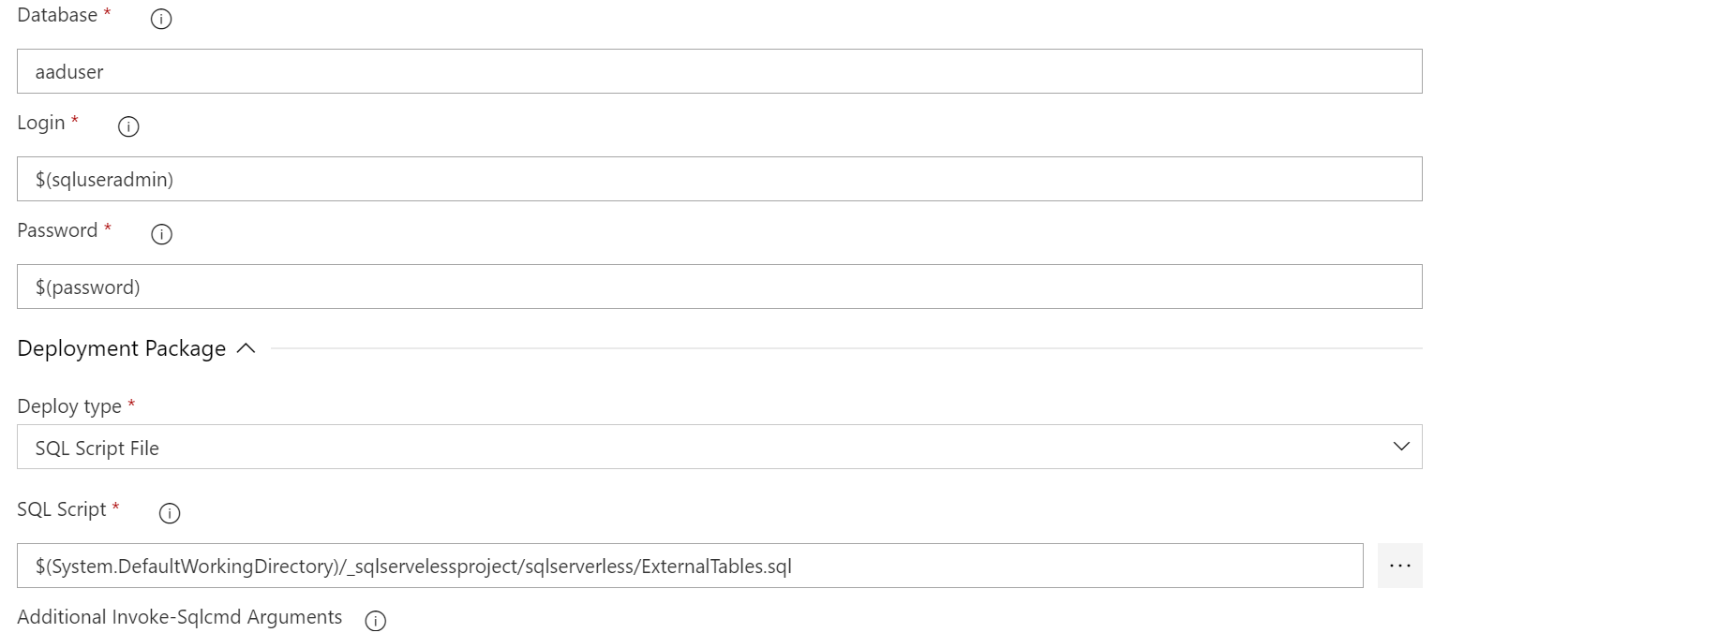

Select save and create a release

1. Test Release Pipeline

Go to Release and click on create release

Add a description and click on create

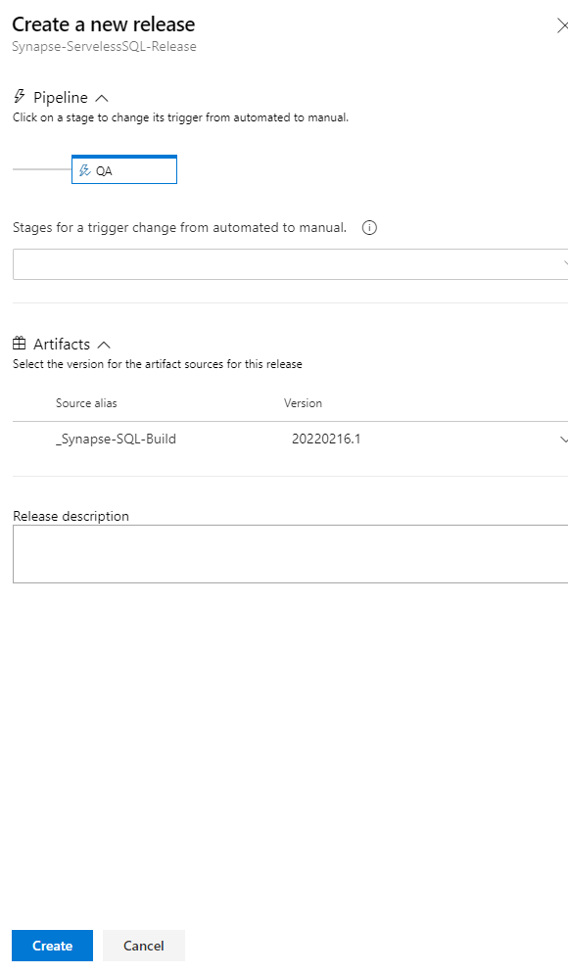

Once the release finishes, you will notice a green box, this means the release completed successfully

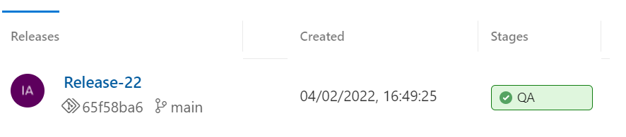

Go to synapse workspace, go to data and check if under the SQL Database you can see the new database and the external created during the release

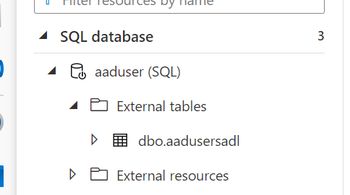

Exercise 9 has been completed

Exercise 10: Synapse workspace artifacts release to QA environment

This exercise shows the deployment of synapse artifacts (pipelines, scripts) using the workspace_publish branch generated by Synapse automatically.

You won’t need to create a build solution for the workspace’s artifacts. In this case we will demonstrate how we can move some synapse pipelines from Dev environment to QA

Tasks

1. Create Release Pipeline

Go to Release under the Pipelines in DevOps

1. Click on New pipeline and select and Empty Job. On Stage give the name of the environment you want to deploy, for example QA.

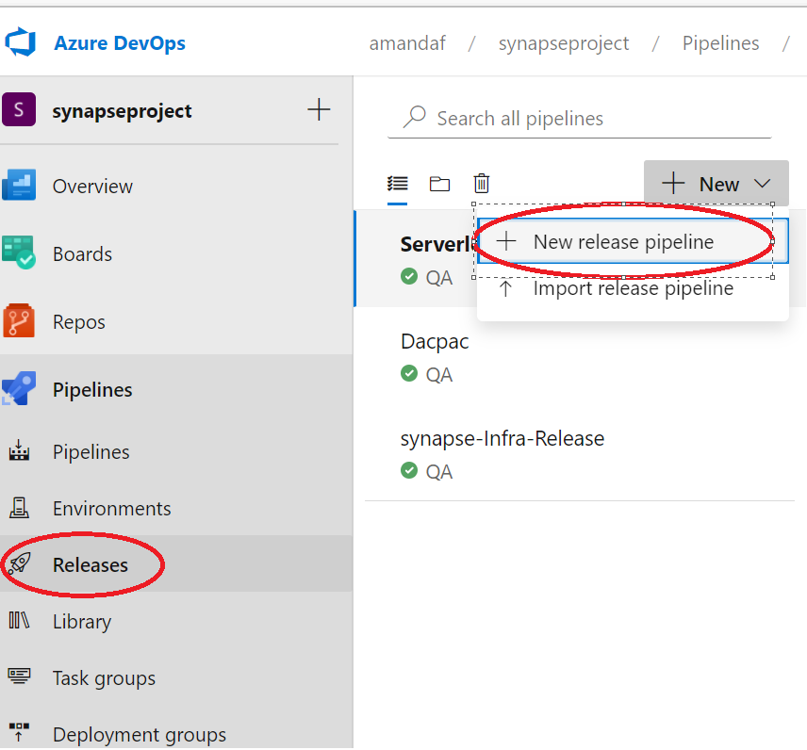

1. Click on Add Artifact, select Azure Repo and select the project, repository, for the default branch please select workspace_publish branch

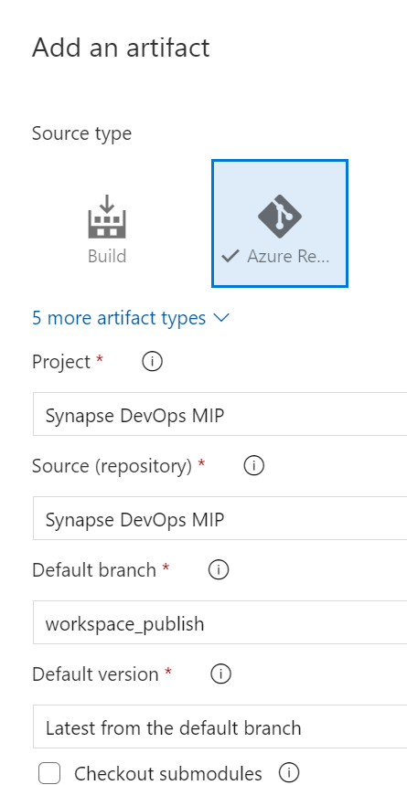

1. Go to Stage 1 and click on the task

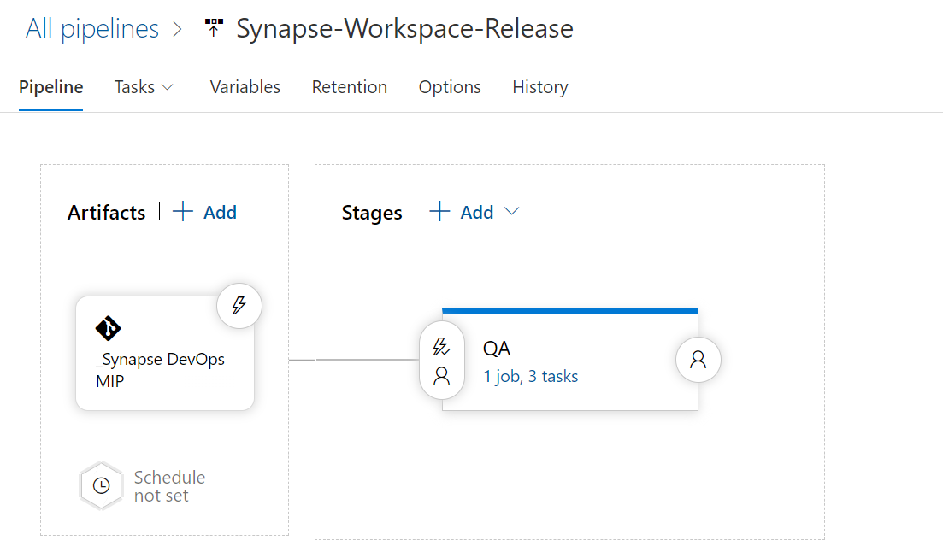

1. Click on the + and search for Stop trigger. Make sure you use the QA resource group and synapse workspace . Leave the rest of the default values

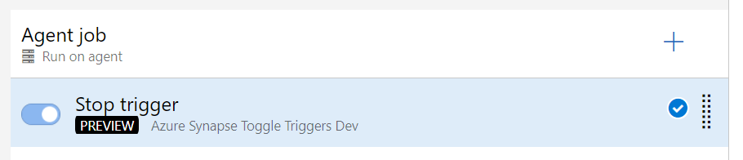

1. Click on the + and search for Synapse deployment task for workspace

Select the template from the linked artifacts.

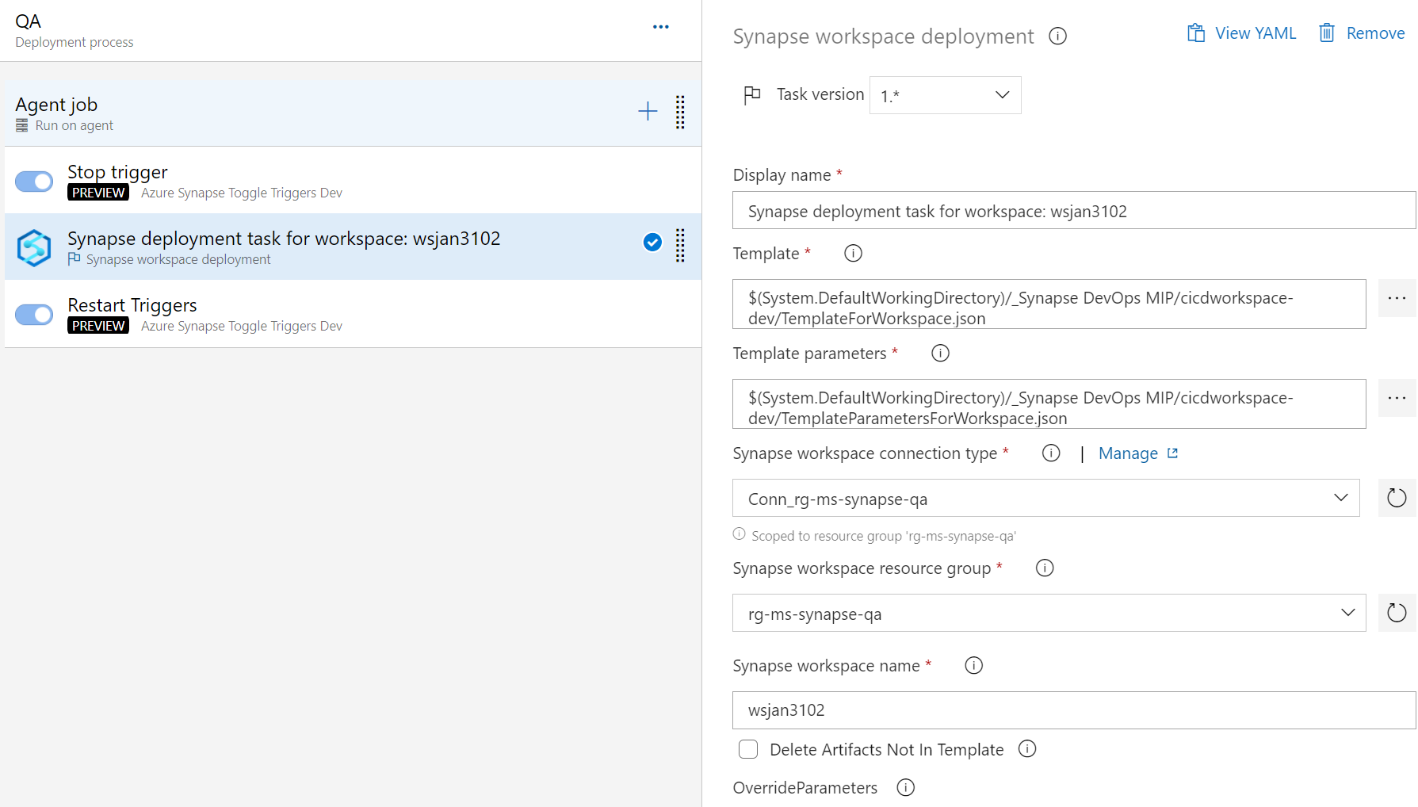

Fill the synapse workspace resource group and the workspace for the QA environment

1. Click on the + and search for Stop trigger. Make sure you use the QA resource group and synapse workspace . Leave the rest of the default values. You can change the name for example start triggers.

Give a name to the release pipelines and save

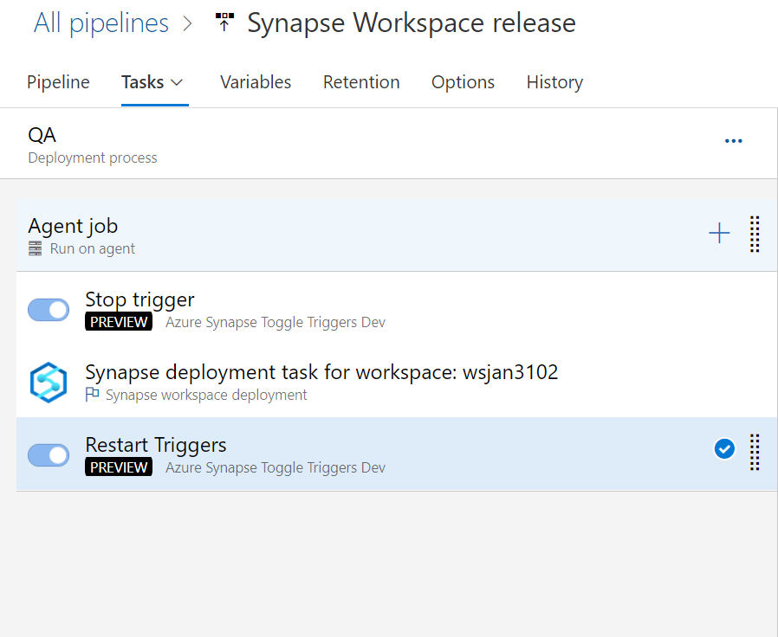

**Note**:- be aware this trigger will also start the dedicated pools

1. Test Release
2. Go to Release and click on create release
3. Add a description and click on create

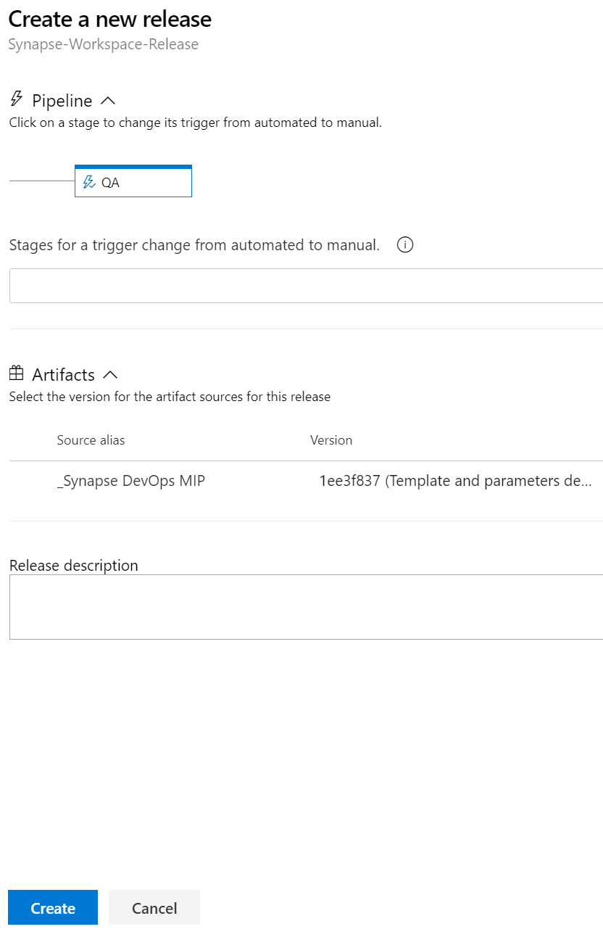

1. Once the release finishes, you will notice a green box, this means the release completed successfully



Go to synapse workspace, you should see a pipeline under the integrate plane

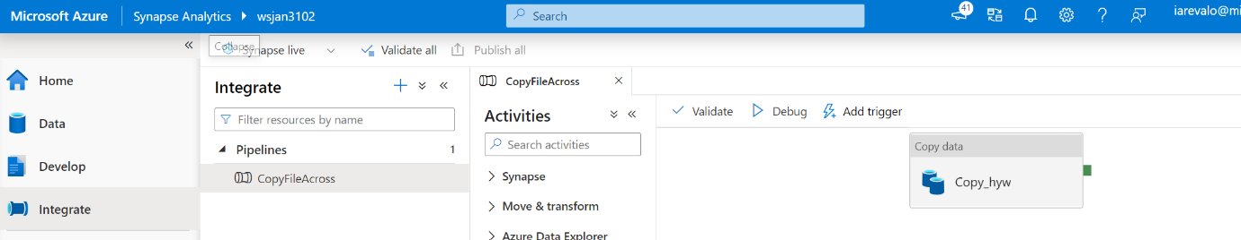

Exercise 10 has been completed